**14 - Fee Lines (Flat Rating) & Adjustment Process on Posted Transactions**

The Fee Line is the process that you will have to go through for to get Flat rate pricing on the Work orders going forward. If you have a Job List (STD Job) against the work order or have converted a Project Quotation to a Work Order, when you create the Fee line for the labour, you will have to delete the Standard Line of labour – see further down the SOP under the Adjustment section. This process is not to be used to transfer labour from work order to the Monthly expensed Work order, or a different business units or branches work order refer to SOP: [7 – Loading & Posting Timesheets - Allowances](https://goughgroupltd.sharepoint.com/:w:/s/GoughGroupKnowledge/EULlHOnuV0tMgzOtYYJpobQBG-xDc4jrAYJmfZSiYrf-9A?e=TFynAW) The Adjustment Process outlined here is how you will transfer between work Orders, change Line Property, and change the Mark-up Percentage on OWM’s that have been fully Invoiced. Instead of creating a Fee Line for the OWM because the mark-up is incorrect use the Adjustment process outlined further through the SOP. P-Card transactions process outlined further through the SOP.

* + 1. **Labour Fee Line - Use only for Labour**
    2. **Parts Fee Line – Use only for Parts and OWM**
    3. **Misc. Fee line – Use only for Consumables.**

1. Go to Work order management > Work orders > Work orders.
2. In the list, Filter using the main or the columns to find your work order.  
   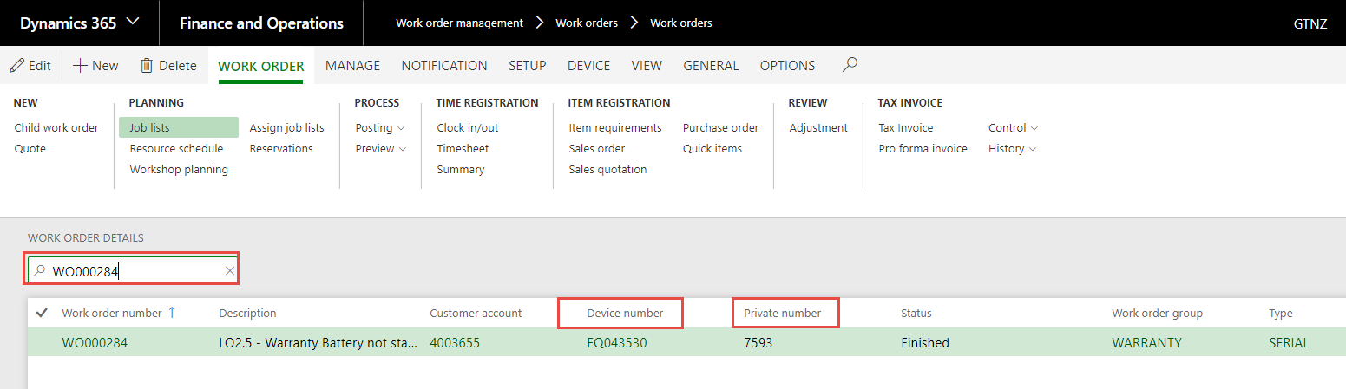

**Fee Line – (Flat Rating)**

1. You need to get the values that you will be creating the Fee lines for.  
   Select View > Transaction > Posted Transactions.  
   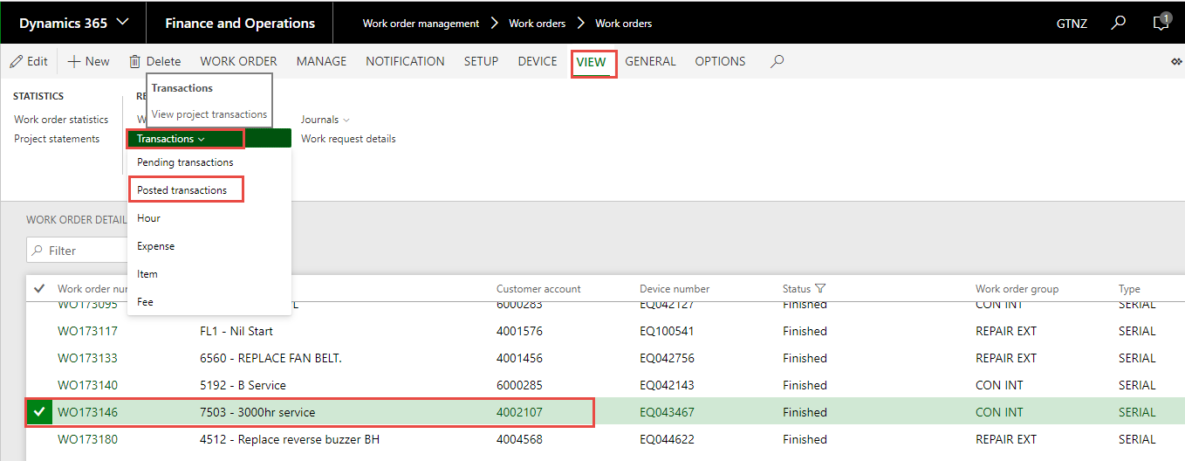
2. You will see all the transactions for the work order that are posted. You may need to export to Excel (1) so that you can filter on the different transactions to get the correct figures for the Journals – it can also be used to help you make sure that you adjust the transactions to NON-CHARGE if you have created the Fee Line Journal.  
   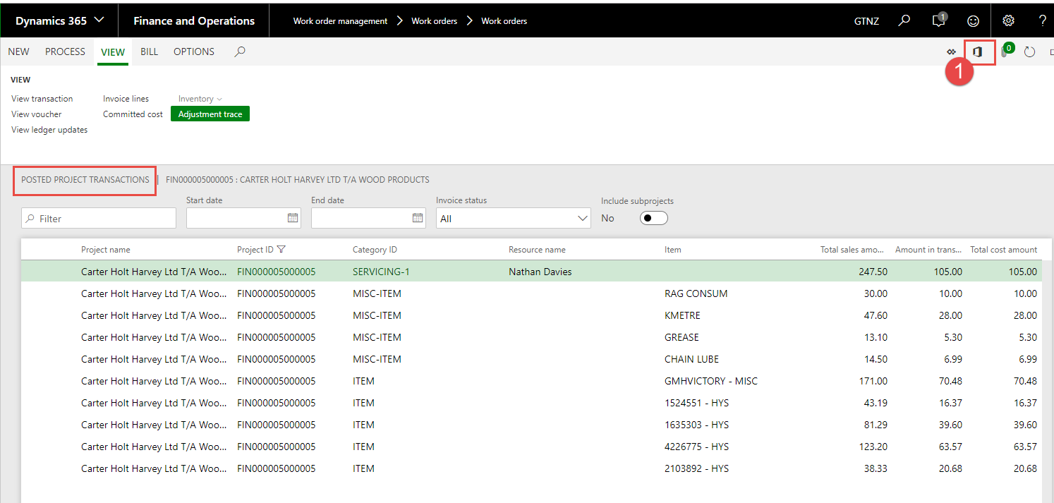
3. If you want to see the quantities associated with the transactions, you will need to Select Transactions > Hour – Item.  
   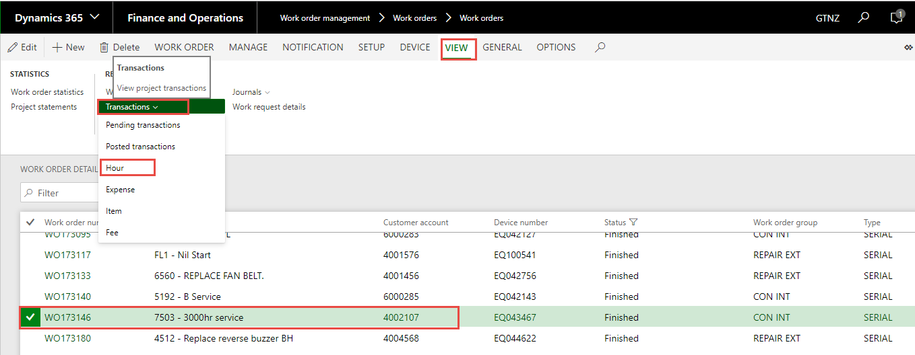
4. As below the quantity’s and Sell Rate appear.  
   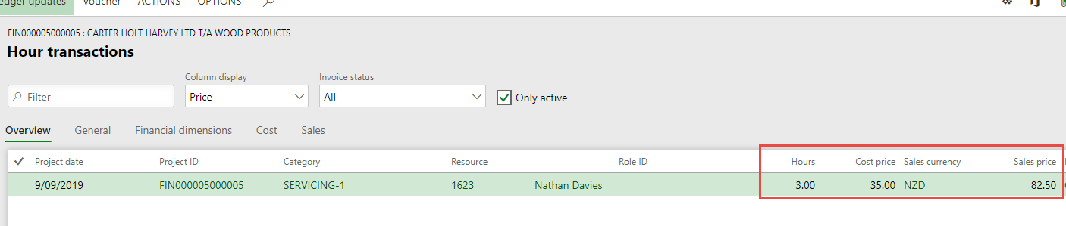
5. Once you have the above data you will be ready to create your Fee Line Journals.
6. Select Manage > Journals > Fee.
7. Select Not posted, Click New, to create the Journal Header.  
   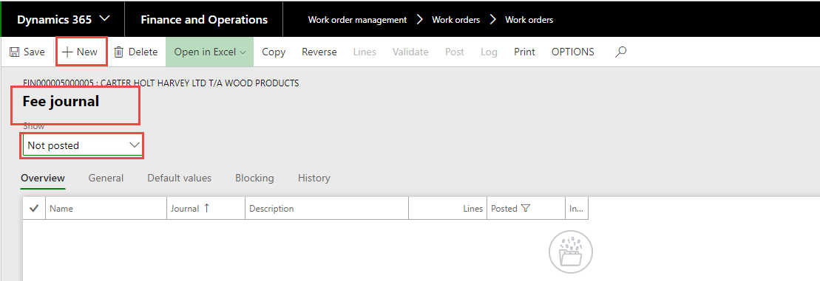
8. Click Lines.  
   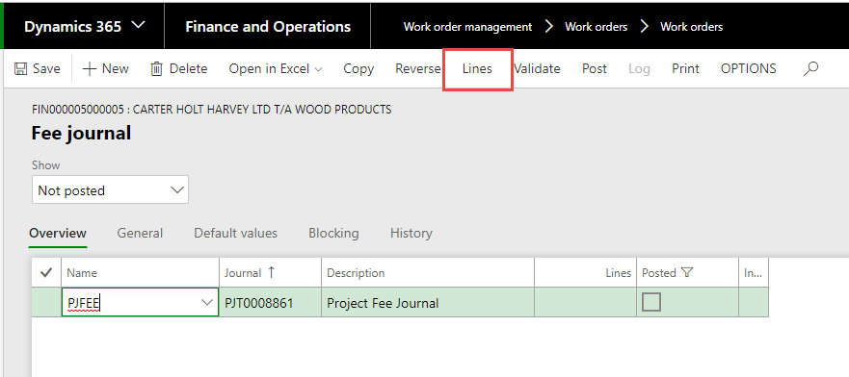
9. Select New, to create a line in the Journal for the details of the Journal.  
   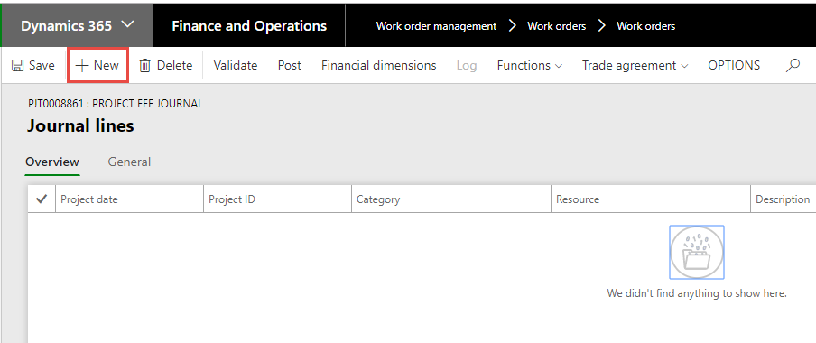
10. New Line appears.  
    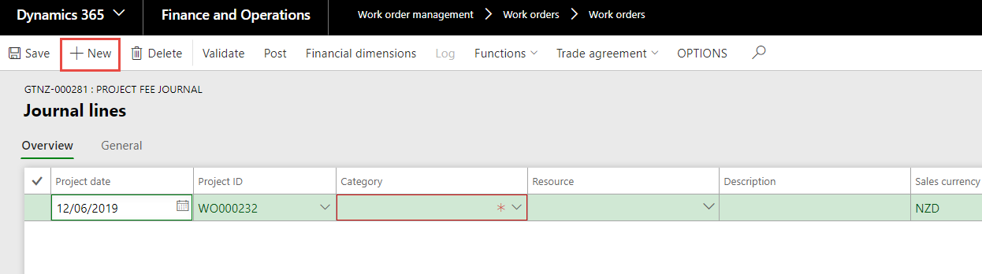
11. In the Category field, Use the drop-down list to select the correct Journal category.  
    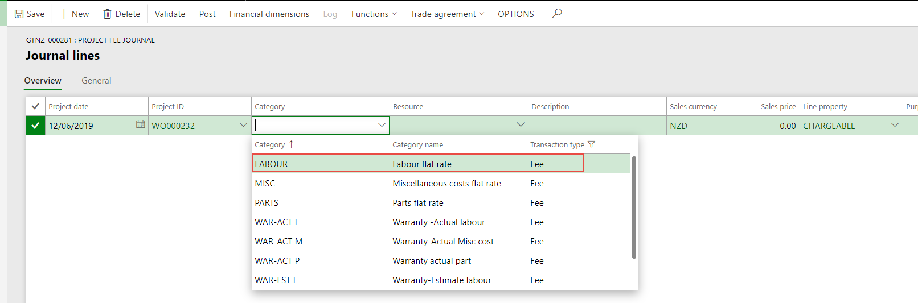
12. In the Description field, type a Description.
13. In the Sales price field, enter the total value for the Journal.  
    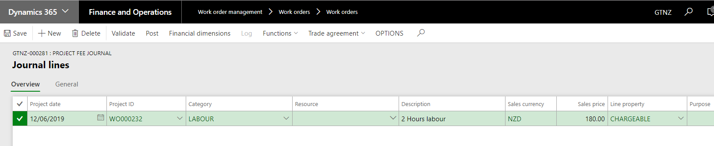
14. Click New. Repeat this process if you want to create Fee Line Journals for **Parts** and or **Misc.**  
    You can post one line at a time if you want.  
    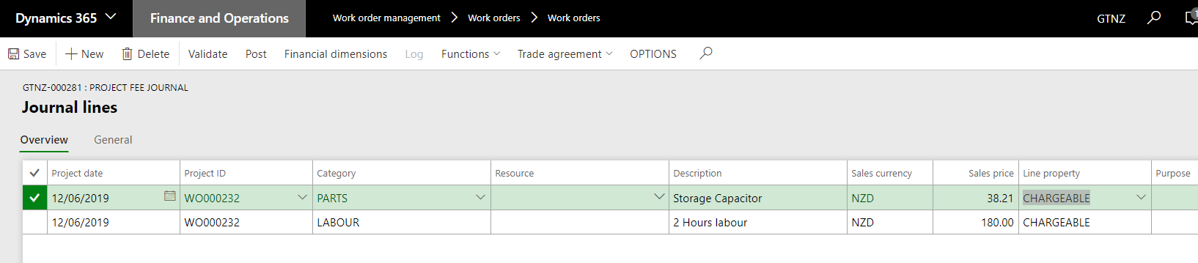
15. Click Save.  
    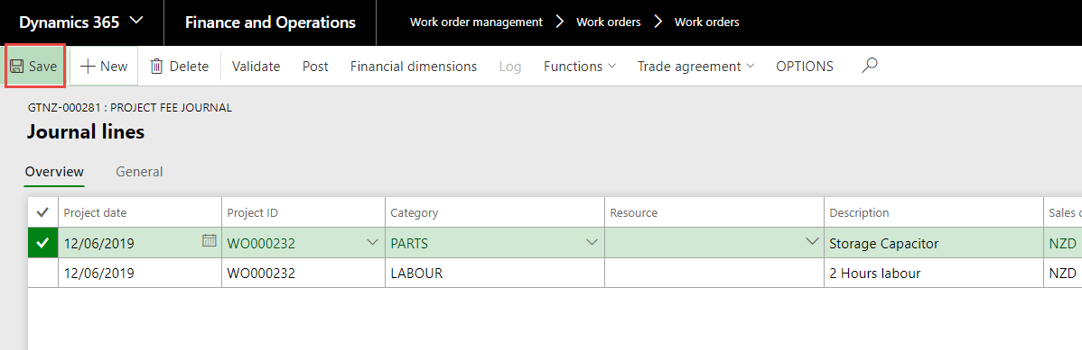
16. Click Post.  
    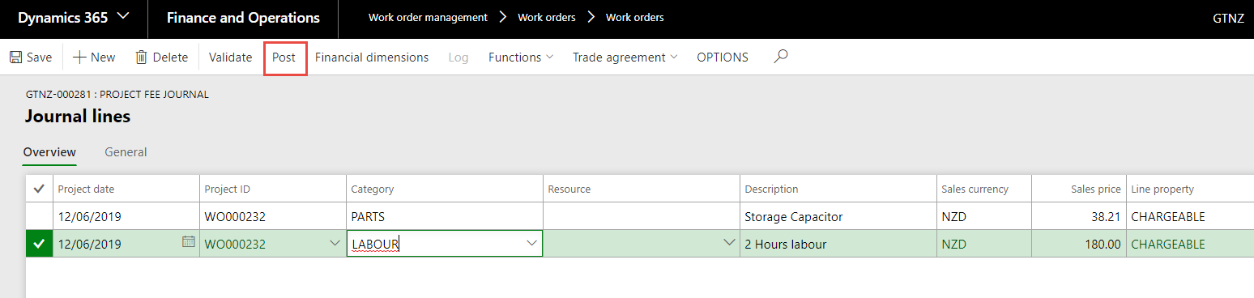
17. Post Journal populates – Select OK.  
    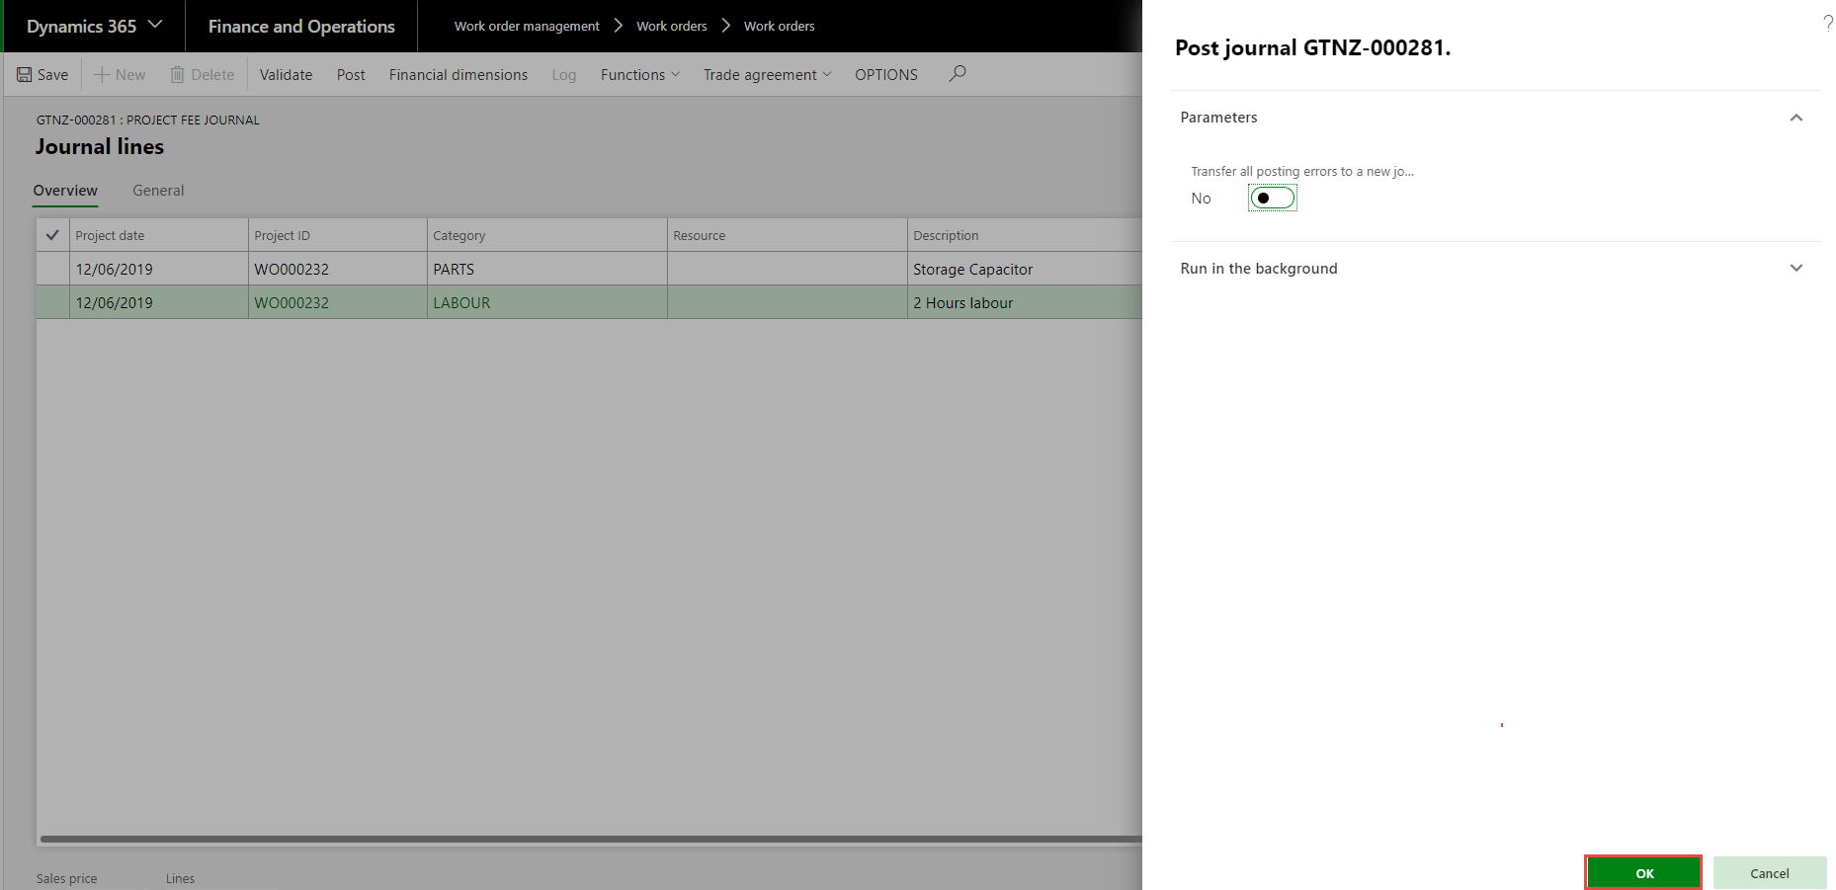
18. You get a message saying that the Journal has posted.  
    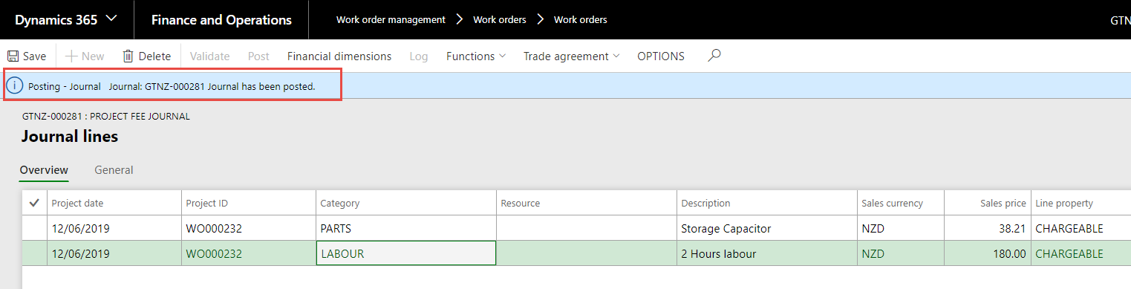
19. Close the page.
20. Close the page.

**Adjust the Posted Transactions.**

This process will handle Adjusting the transaction from Chargeable or Non-chargeable. Changing the Category, Transferring to another work order or child. When you have created **Fee Lines** you need to make those transactions **NON-CHARGE,** this can be done altogether instead of individual transactions (see Bulk Transfers and Adjustment Process)**.** Remember that Work orders with Work order Group MOD INT their transactions will already be NON-CHARGE so don’t alter them to Chargeable. You should not adjust the Mark-up Percentage or transfer OWM until the Purchase Order is Fully Invoiced (check the Purchase Order to confirm the status).  
**NOTE WE HAVE AN ISSUE WITH THE PARTS AND CONSUMABLES TRANSFERING TO A DIFFERENT WORK ORDER, IT IS NOT PICKING UP THE CUSTOMER PRICING AGREEMENT. We have lodged a Ticket, but we don’t have a time for the fix so in the meantime you will need to follow a different process. It is outlined at the end of this SOP.**

1. Work order > Review > Adjustment.  
   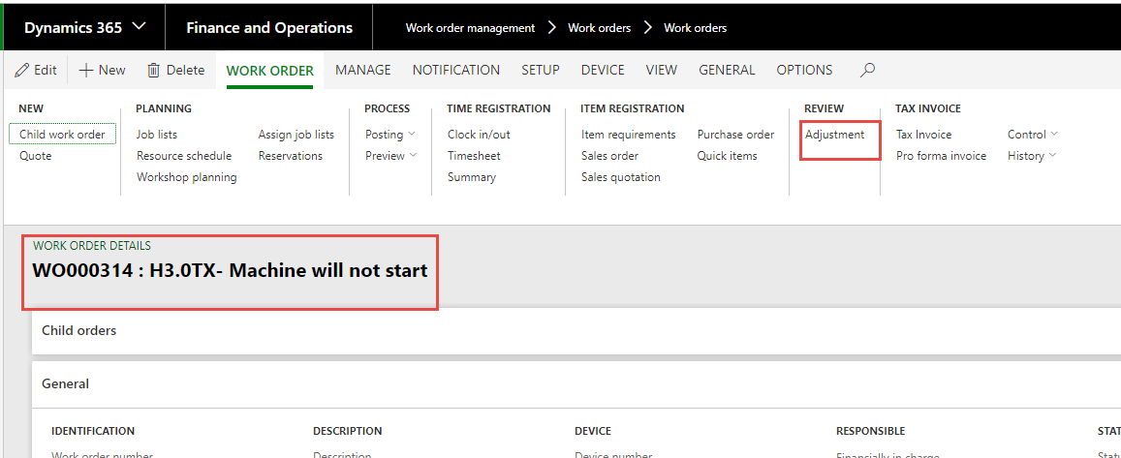
2. You see a list (Tree) out to the left that represents the transactions on the work Order.  
   1. = Work order header  
   2. = Transactions  
   3. = Child Work Orders  
   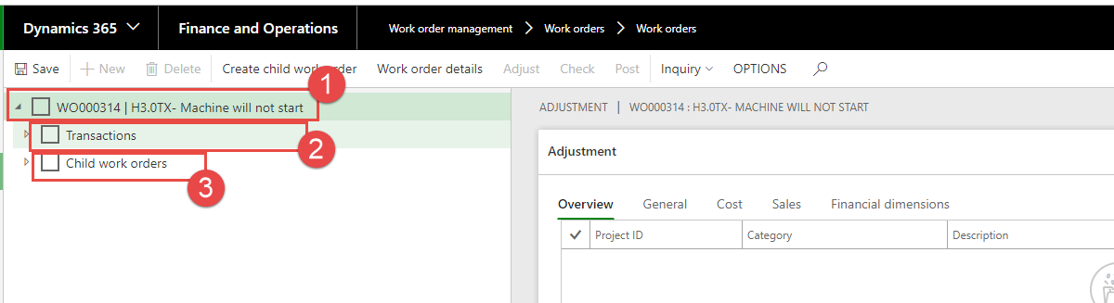
3. When you expand the transactions, you will see all the transaction against the work order.  
   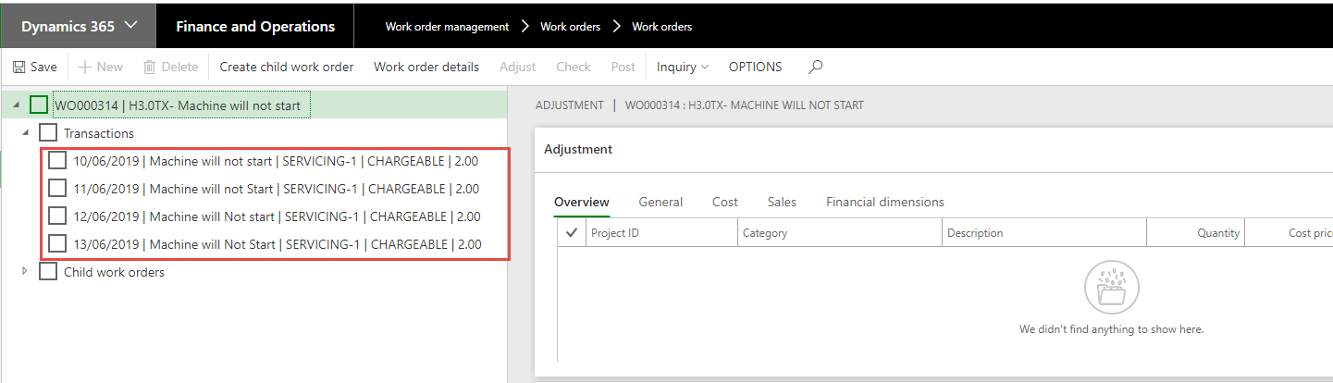
4. You can click Transactions which will tick all of them or you can just tick one or two.  
   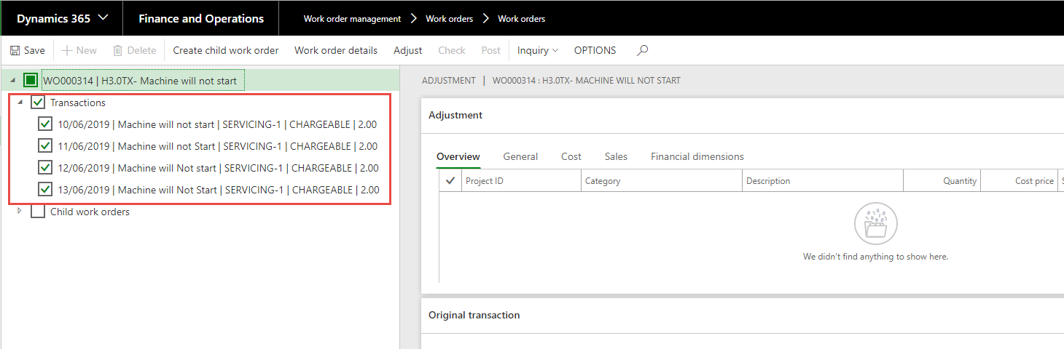  
   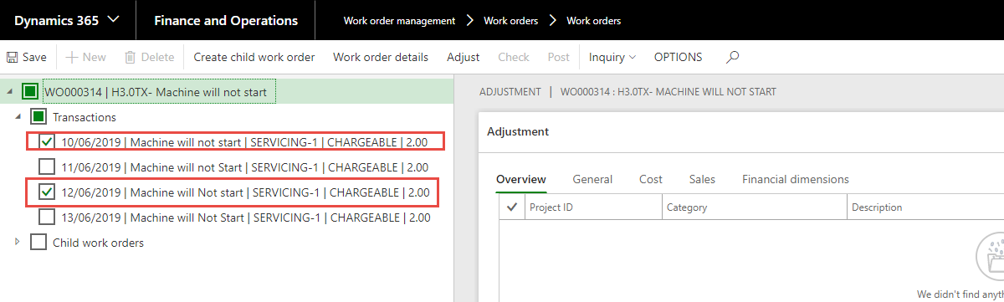
5. You can choose to highlight all transactions and then just adjust the ones that you want. The exception to this is OWM which will be handled on their own. (note further through the SOP).
6. Make sure that you Highlight one of the selected lines, then the adjust button will be available to be selected. Select Adjust.  
   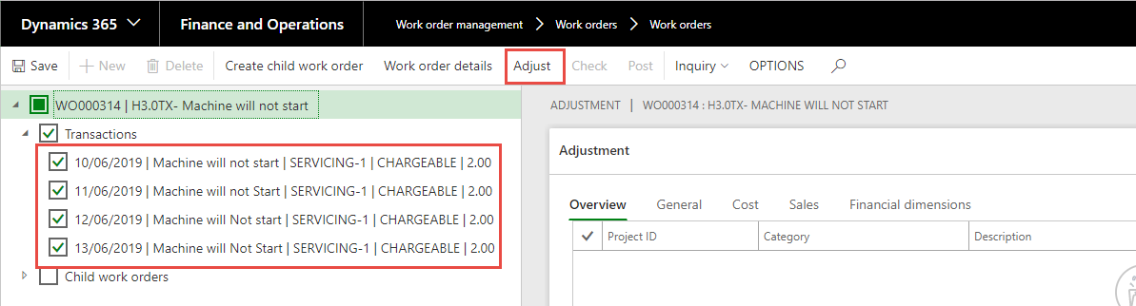
7. Adjust transactions comes up – make sure that you have the selects set correctly as per below - select OK.  
   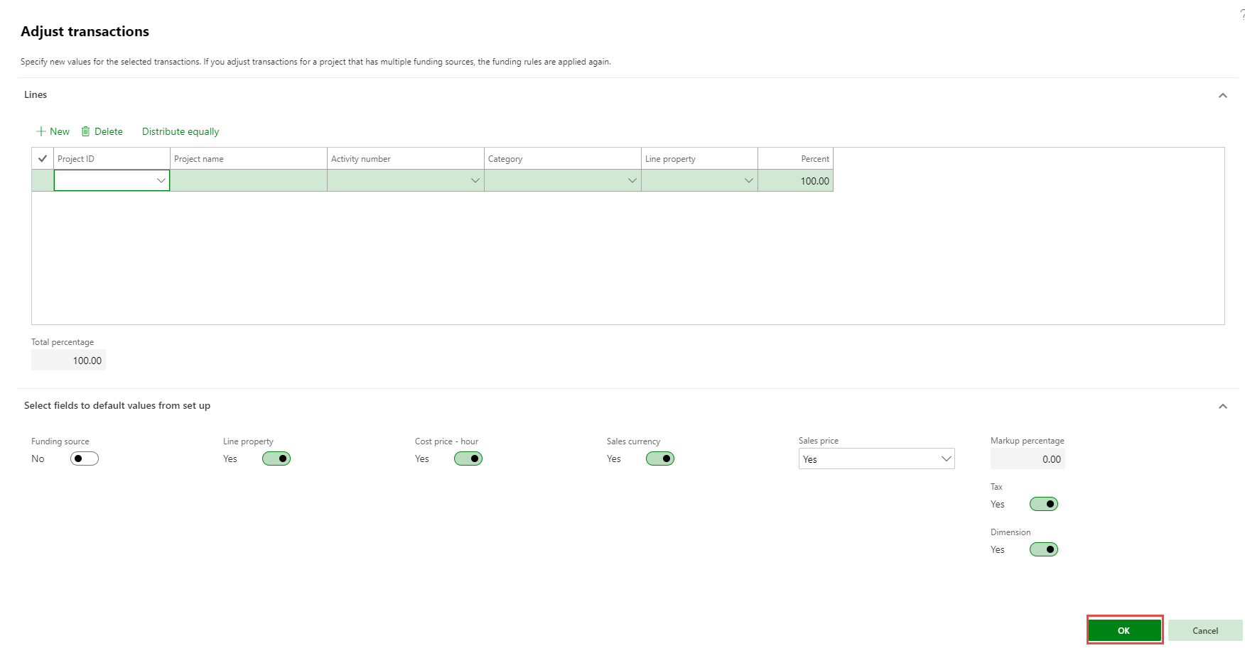
8. You now have all the transactions in one list.  
   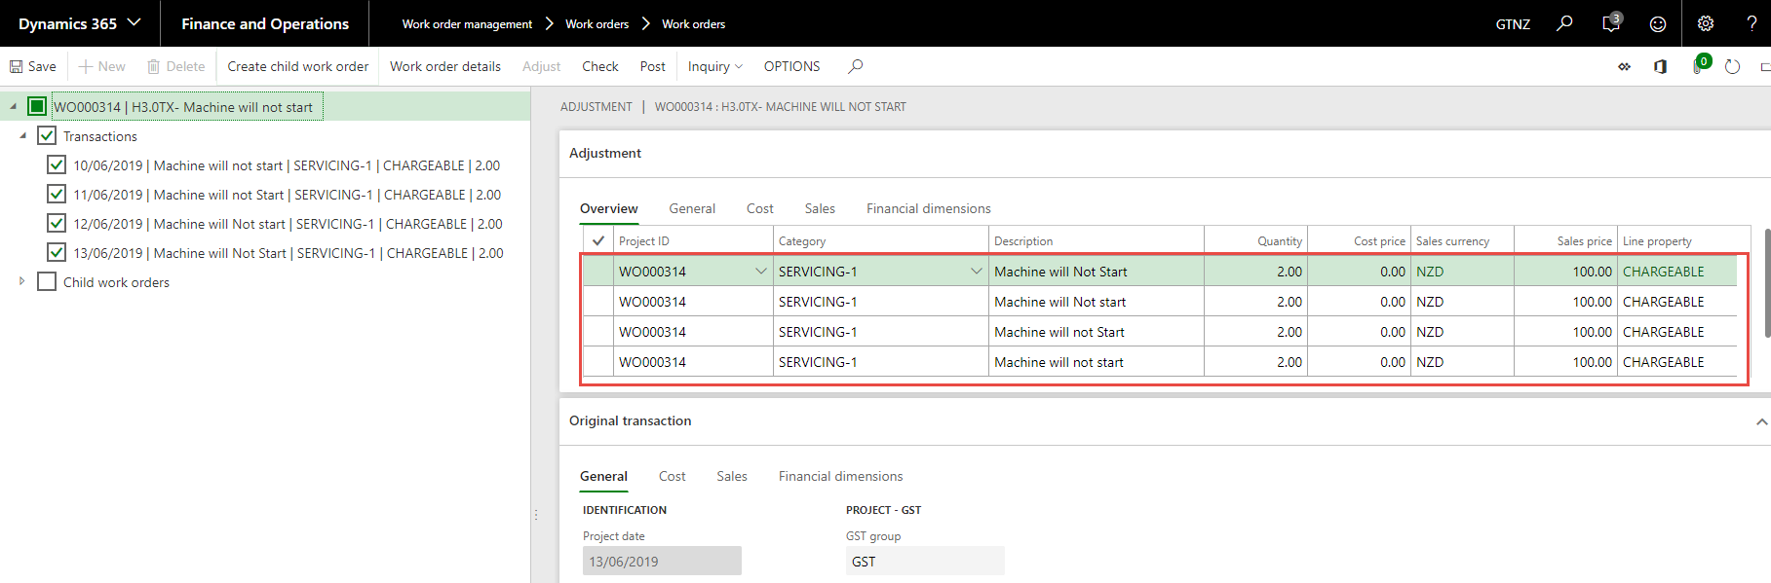
9. You can change the Category to a different one – Standard or Servicing 2.
10. Change the Work order number (project ID) and you can change the Line Property to NON_CHARGE.  
    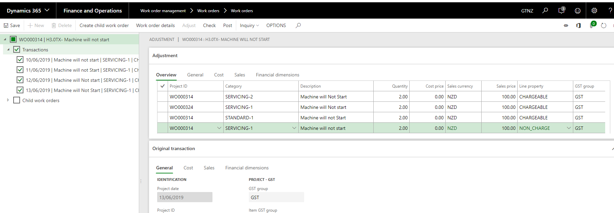
11. You need to save and then post.  
    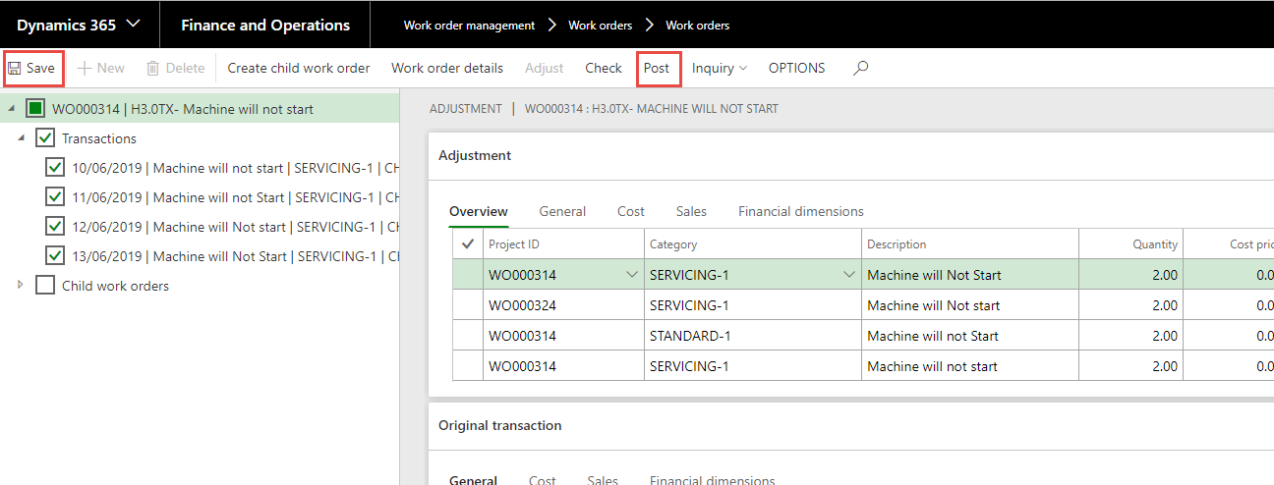
12. Confirm changes and post adjustment.  
    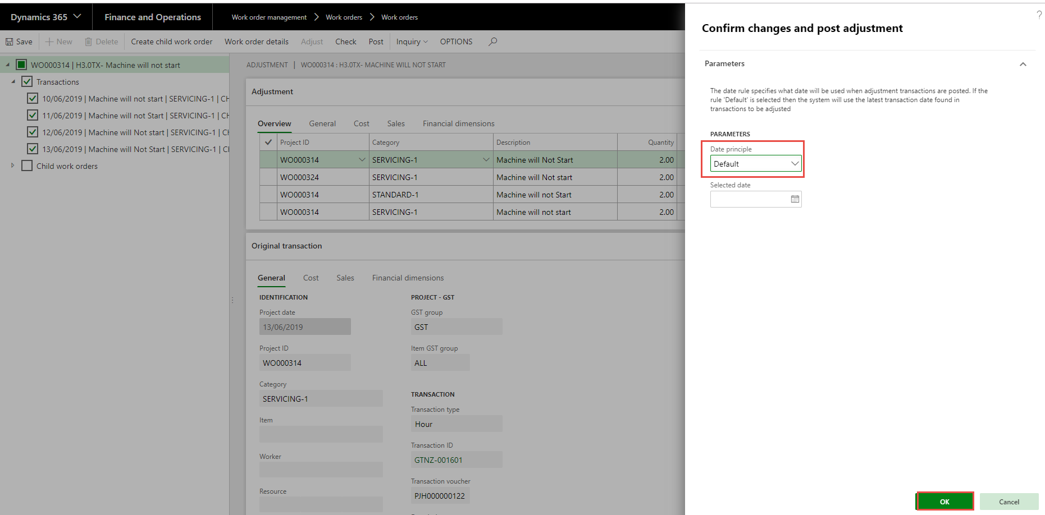
13. You get a message transaction updated.  
    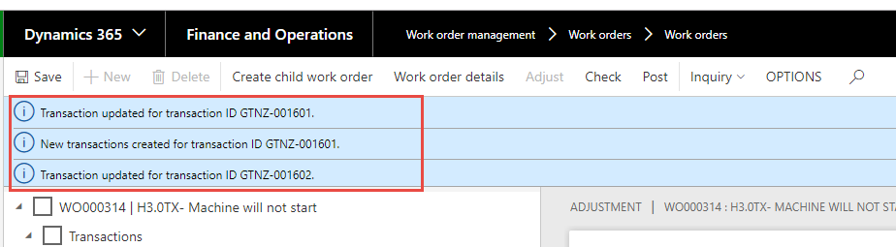
14. If you open the transactions, you will see that they have changed  
    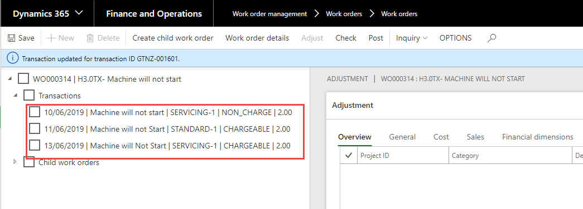
15. Continue until you have adjusted all the transactions required. Close.
16. **When you want to Transfer the OWM to another Work Order,** **you first need to check the Purchase Order to confirm the Status is Invoiced/Confirmed.**
17. Select the Work Order > Adjustment.  
    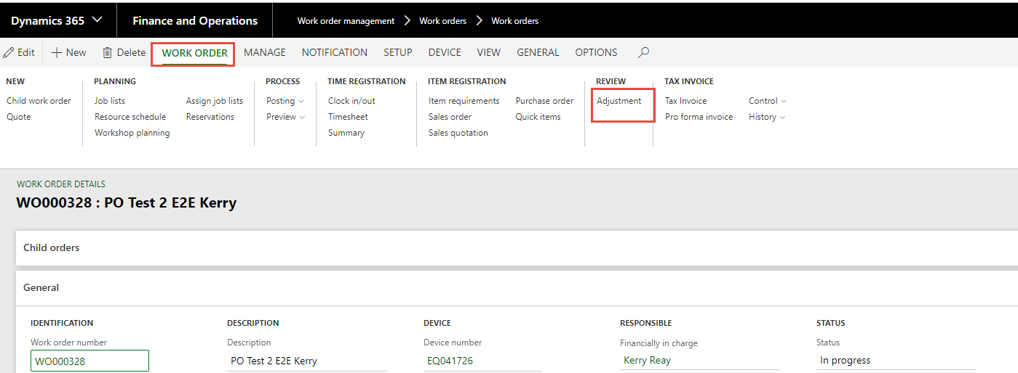
18. Open the Transactions and Select the OWM you want to transfer or adjust. Remember you need to make sure that the OWM is Fully Invoiced or you will lose pricing when adjusting. Make sure that you have the line highlighted then the adjust button will be available.  
    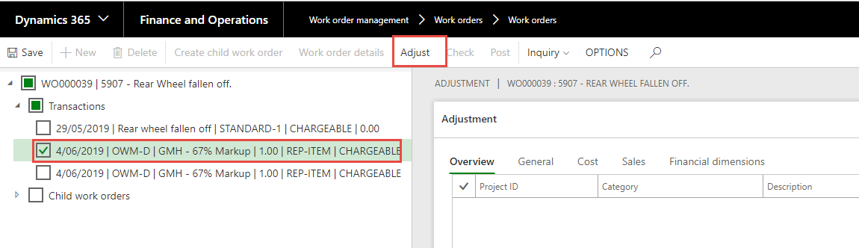
19. Adjust Transaction - Change the Sale Price to **No** and then OK.  
    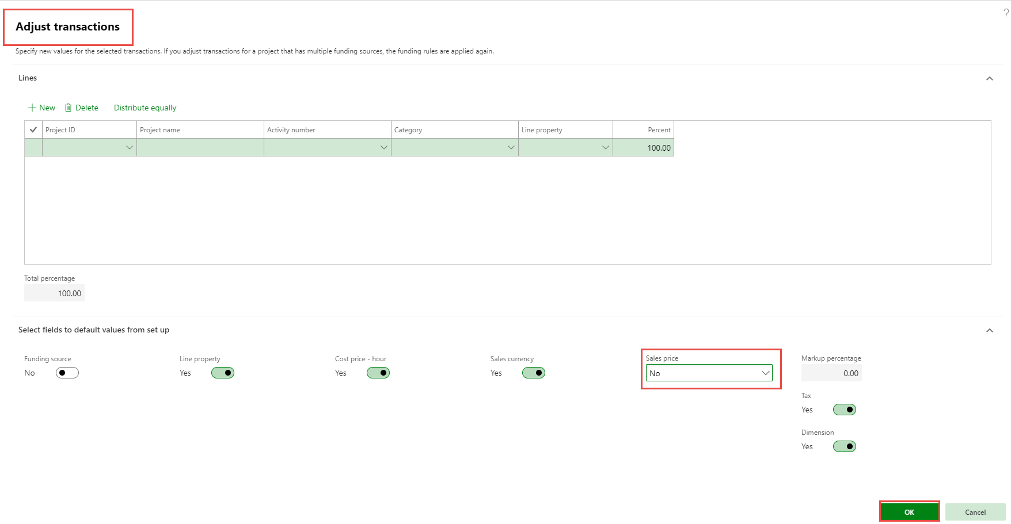
20. You now see the Work Order and line.  
    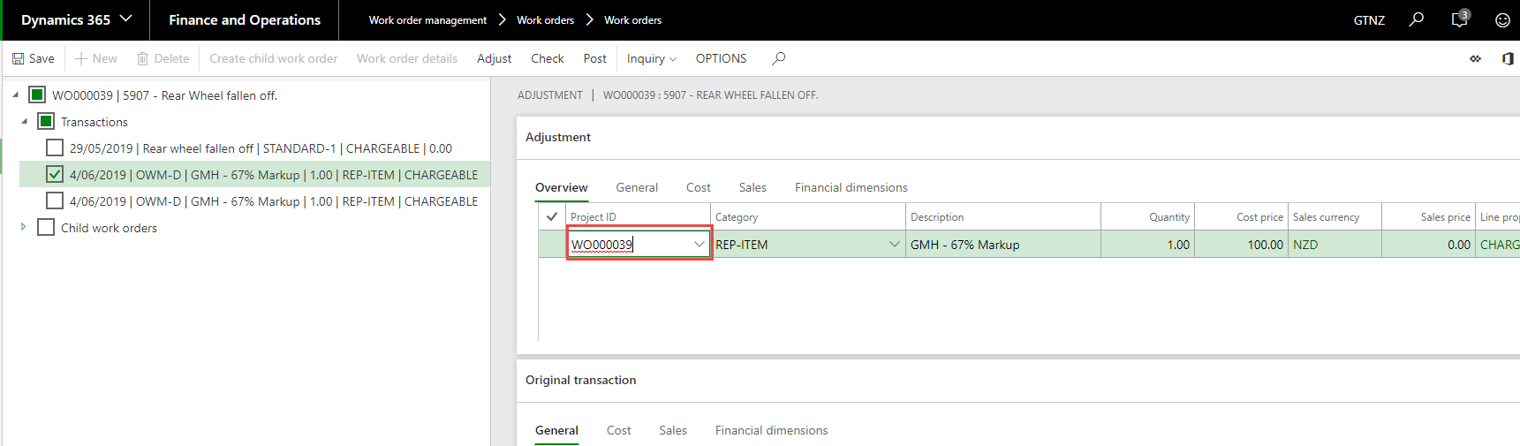
21. Change the Work Order number (project ID), or price.  
    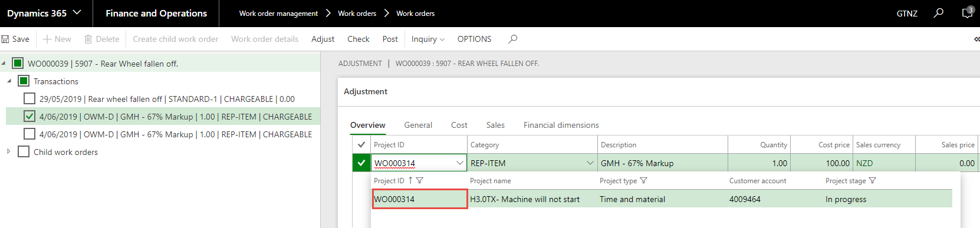
22. Save and then post.  
    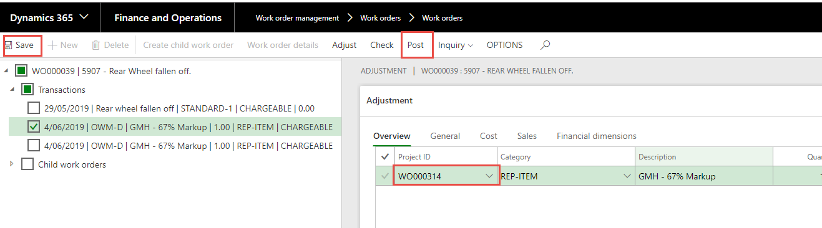
23. Confirm changes and post adjustment – Select OK.  
    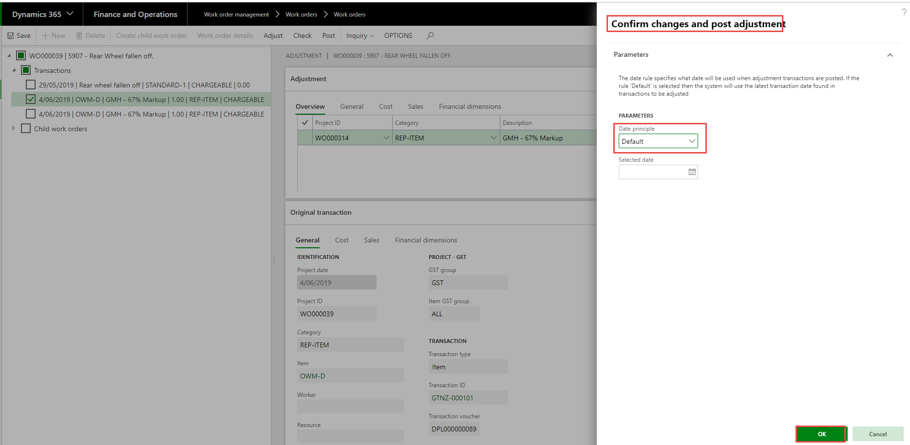
24. You get message that you have transferred.  
    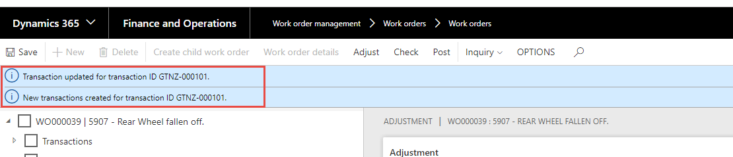
25. You see that only one transaction is there.  
    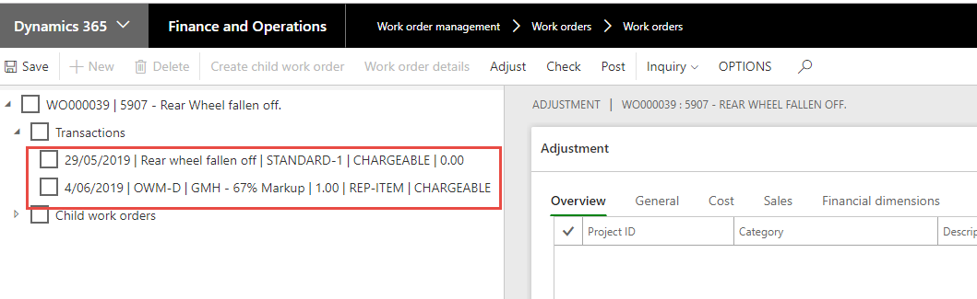
26. Close.
27. **When you want to Adjust the Mark-up on the OWM the Purchase Order needs to be fully Invoiced before you.**
28. Work order – Select Adjustment.  
    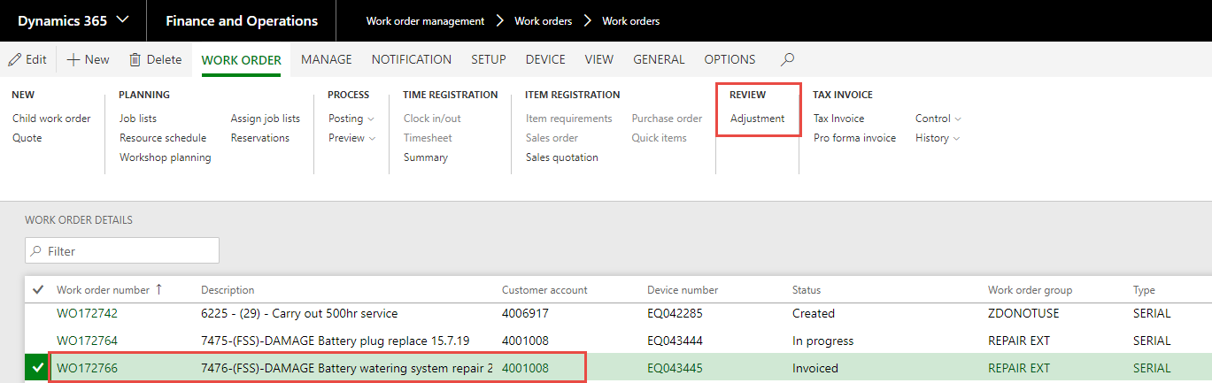
29. Select and highlight the OWM you want to adjust the mark-up – Select Adjust.  
    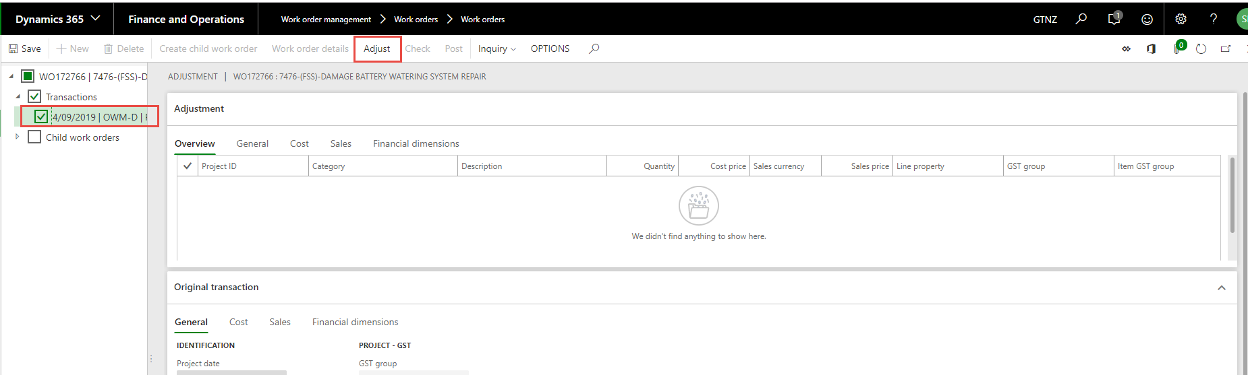
30. Adjust Transactions for appears – In the Dropdown options for Sales Price you select Mark-up Percentage.  
    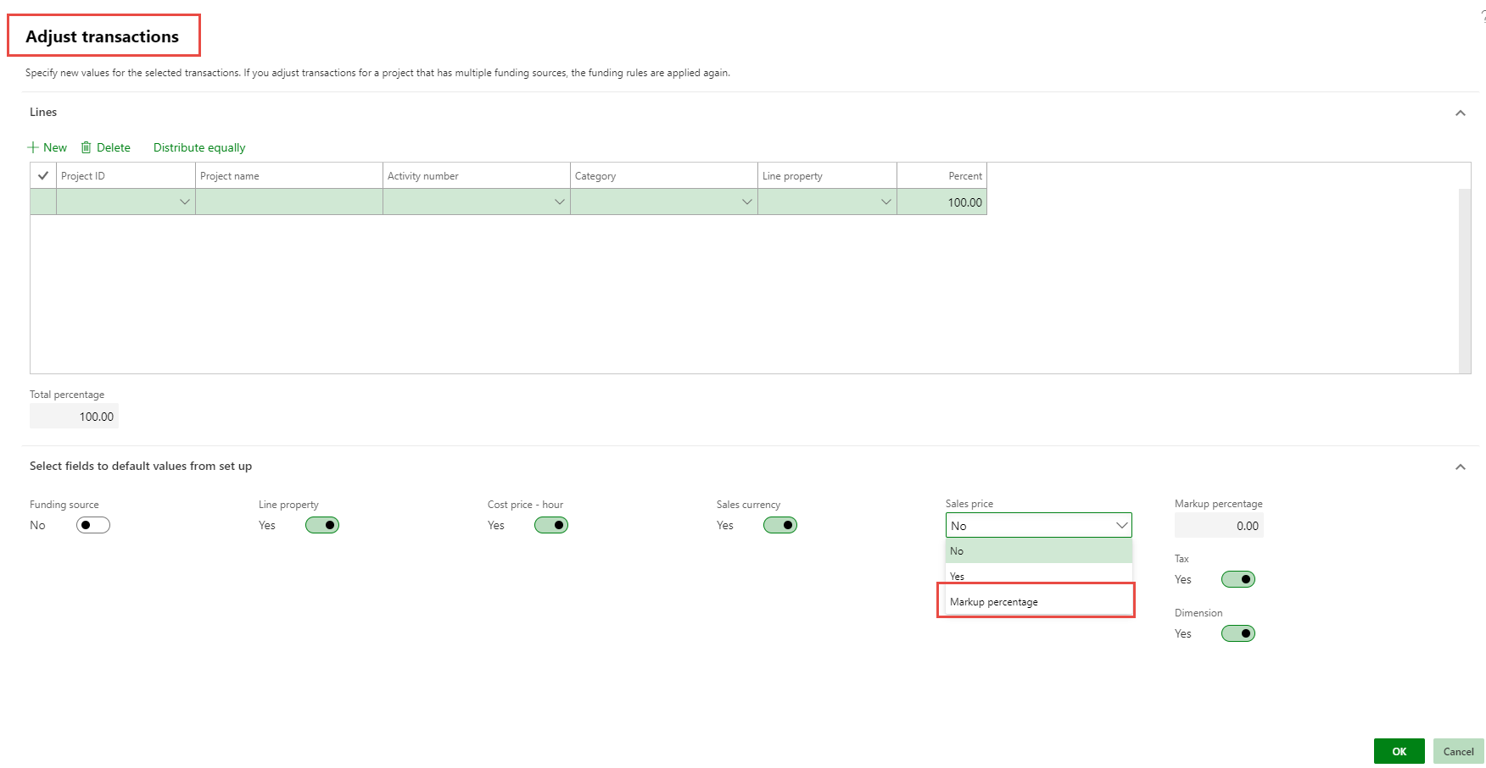
31. The Mark-up Percentage filed becomes available – you populate the correct Percentage required. OK.  
    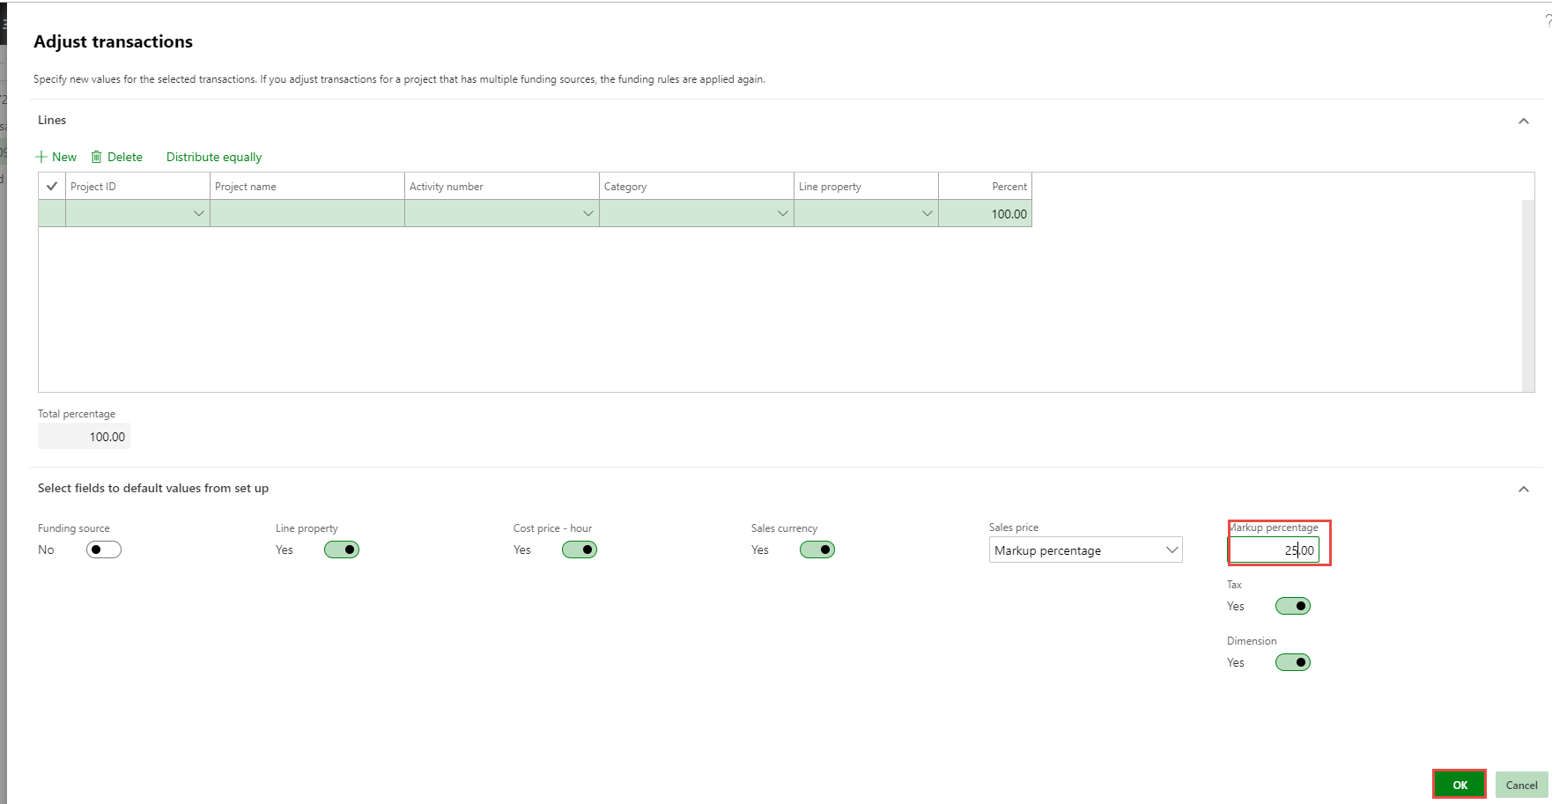
32. Adjustment – show that you now have only 25% on this OWM – Post.  
    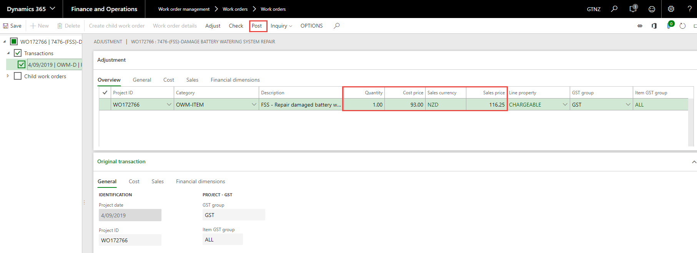
33. Confirm changes and post adjustment – Select OK.  
    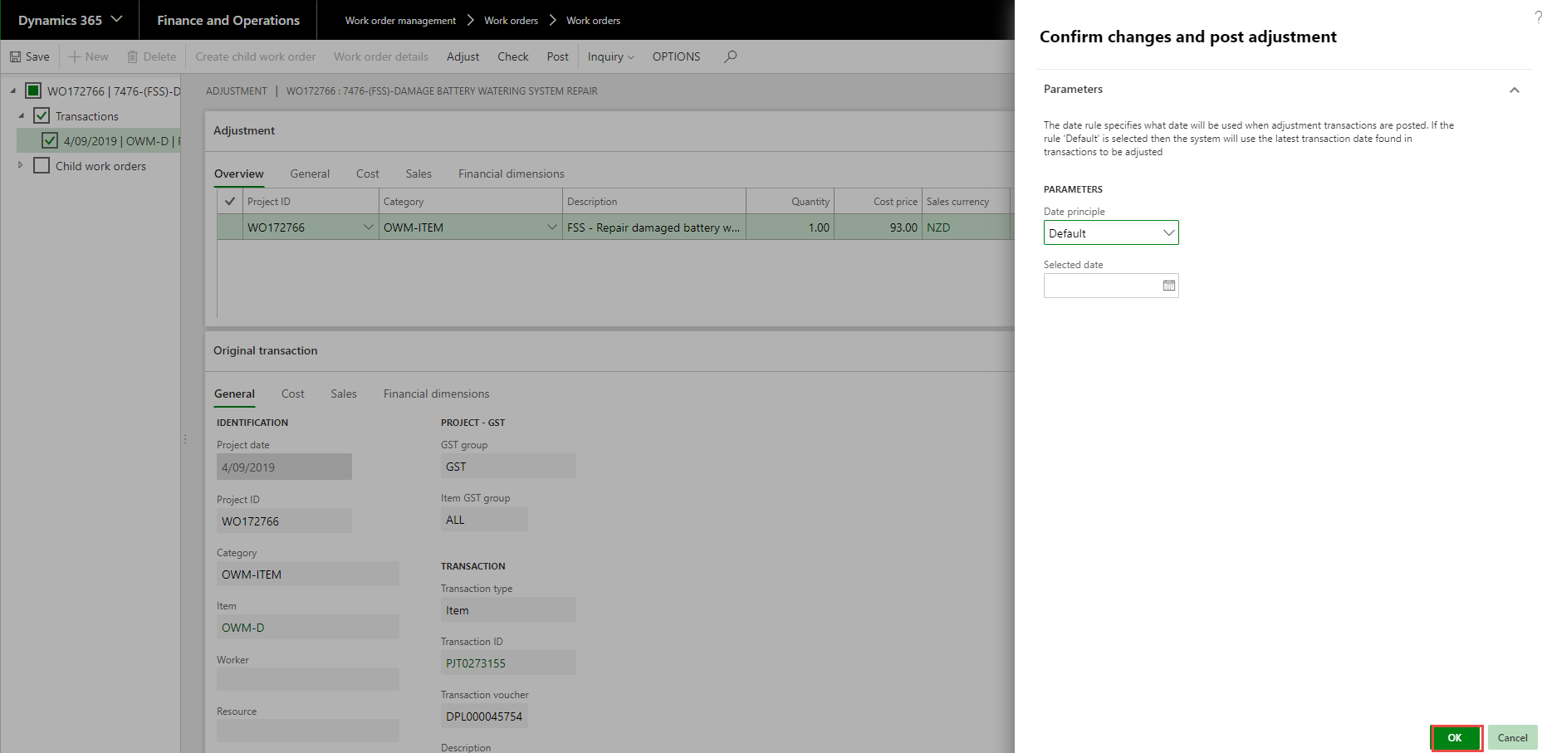
34. Close.
35. Posted transactions show the cost and Sell.  
    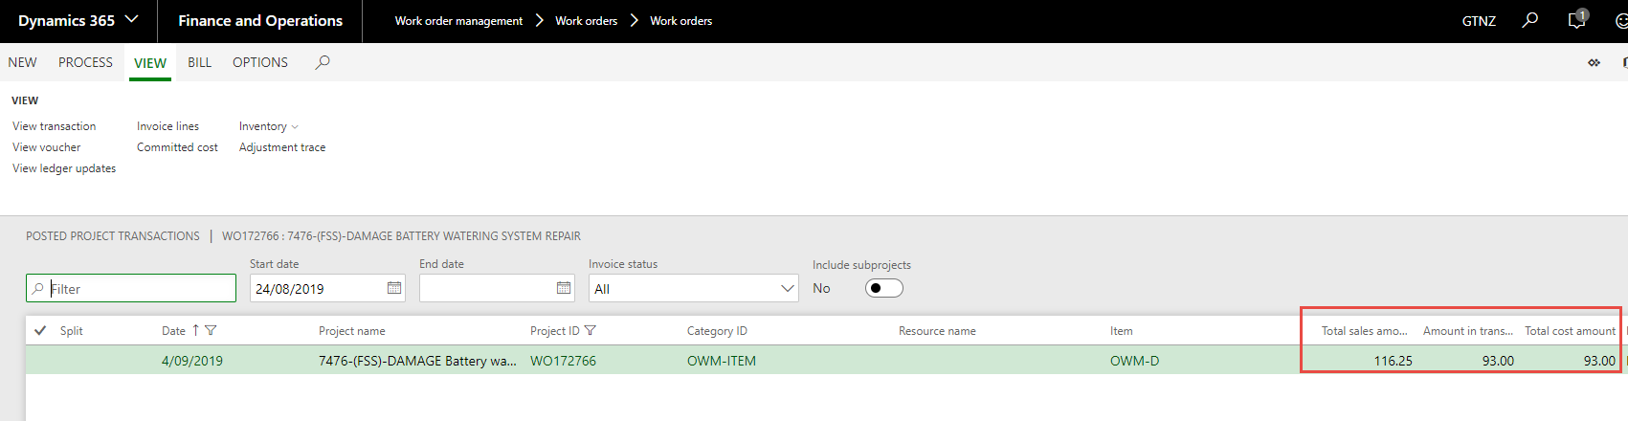
36. Close.

**Bulk Transfers and Adjustments process.**

This process will make all transactions Non-Chargeable or Transfer all transactions to new work order. BUT remember if you are selecting OWM they must be done on their own.

1. You want to make all or some of the transaction NON_CHARGE – you will select all the transactions by ticking the box next to Transaction Header.  
   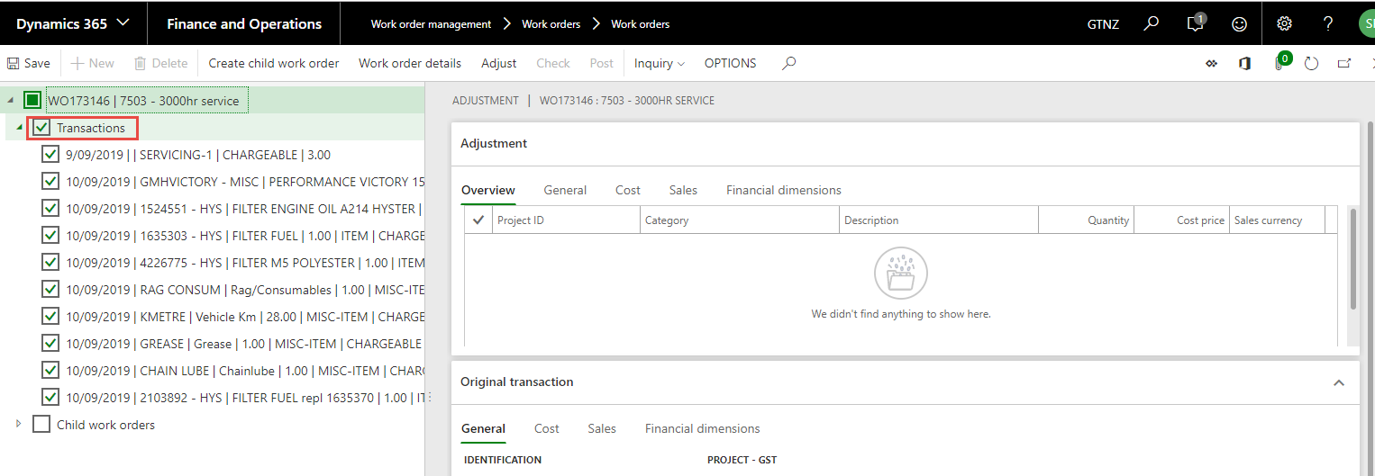
2. You can unselect the transactions you don’t with to adjust or transfer.  
   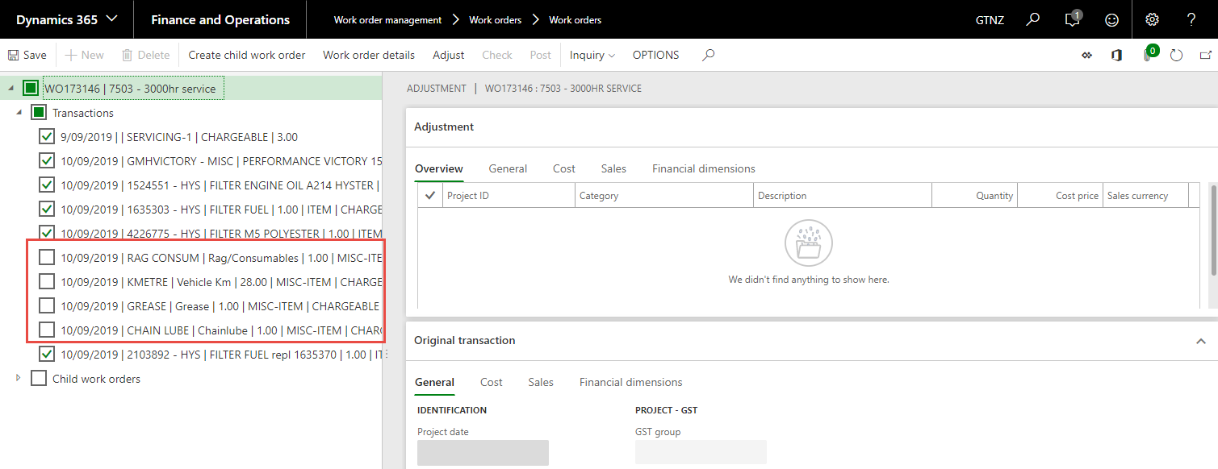
3. Select Adjust.  
   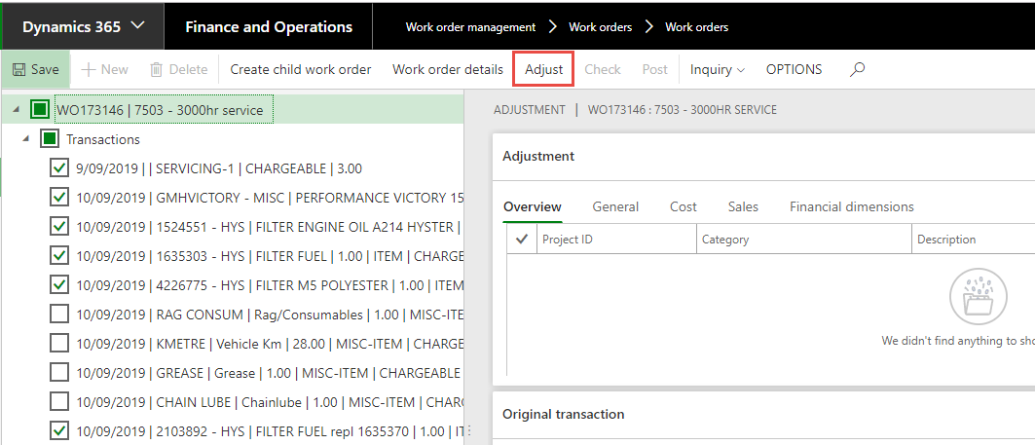
4. Adjustment transactions form appears – you can select here to change all the transactions to NON_CHARGE.  
   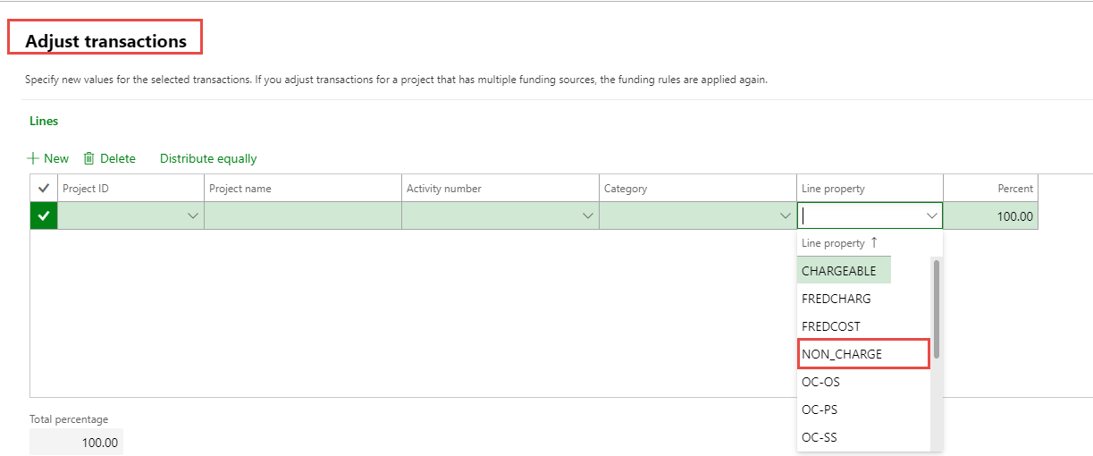
5. Check that the default values are set correctly (remember OWM Sales Price will be. NO)– Select OK  
   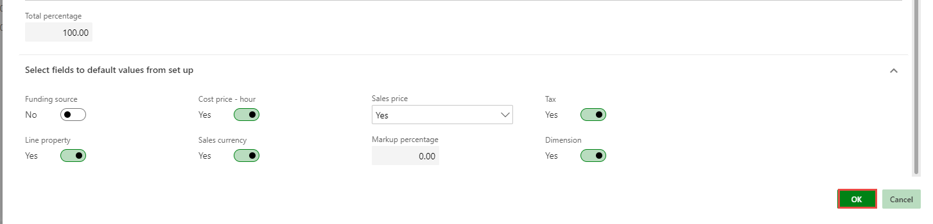
6. You will see that all the transactions in the Adjustment screen have a line property of NON_CHARGE. Check them and if you they are correct – Select Post.  
   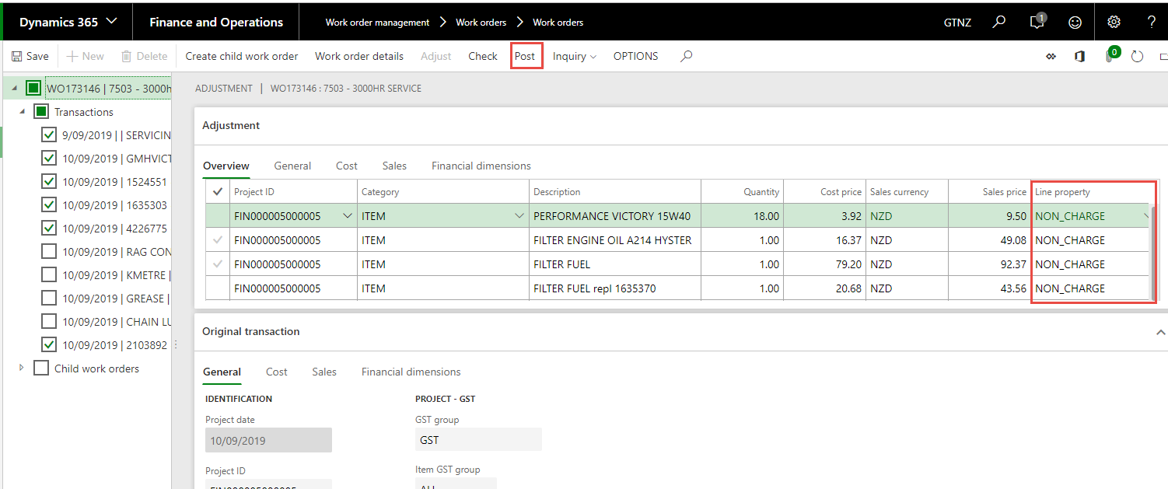
7. If you are transferring to a new Work Order you can populate the new Work Order here and it will populate it on the Adjustment screen – the same as the above.  
   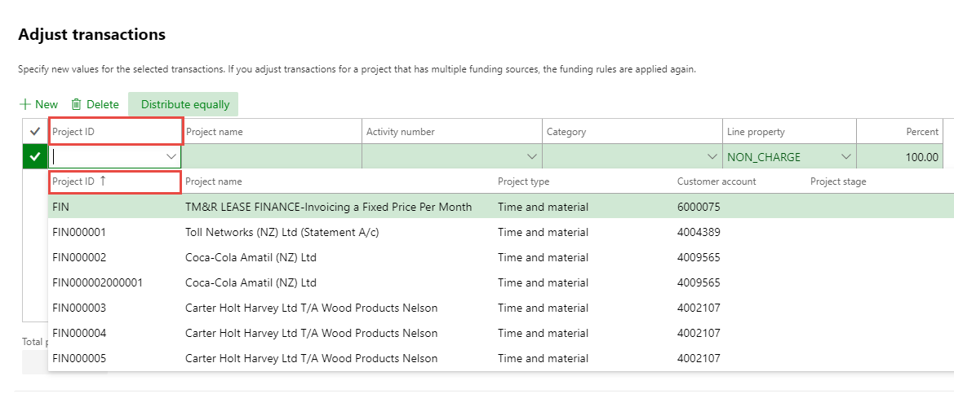

**P-Card Adjustments**

**We have an issue with the P/Card transaction when you try to Invoice the work order – Annata-159531 – See notes at end of SOP. You still need to do the adjustment for the value and the description as per below.**

1. The P-Card has come through against the Work Order and you know that the Description and the Price are incorrect – you need to use the Adjustment Process to amend these.
2. Select View > Transactions > Expense.  
   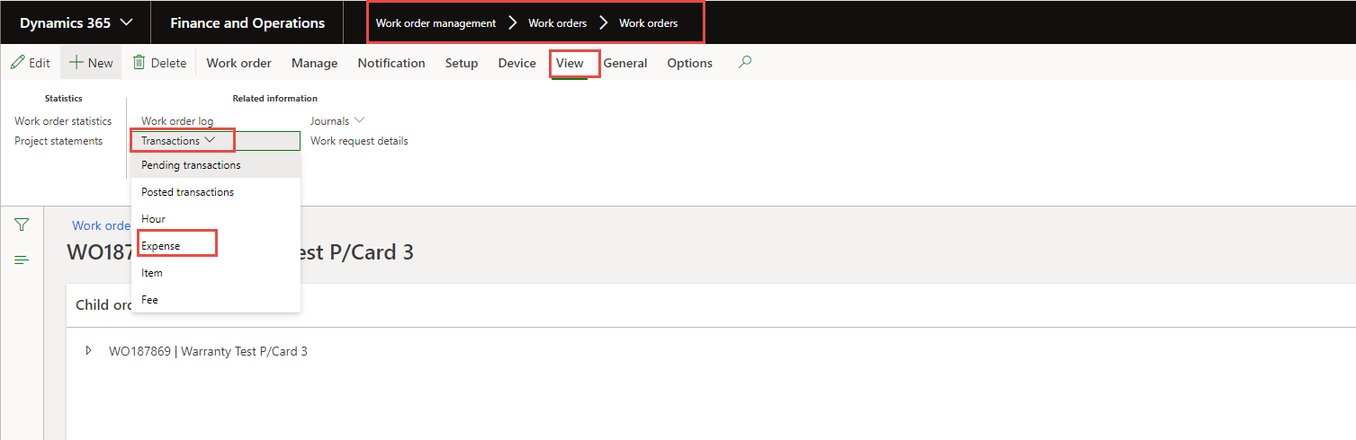
3. You will see the transaction; it will have the same for the cost as the Sales also the resource or Description may not be what you want the customer to see.   
   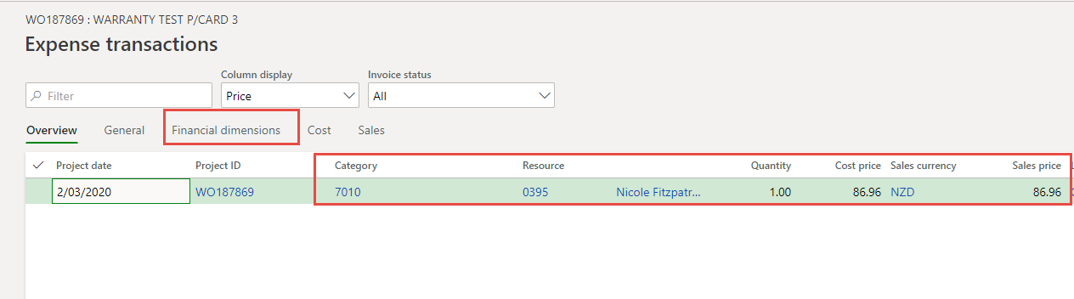
4. You Select the Work Order TAB – Review > Adjustment.  
   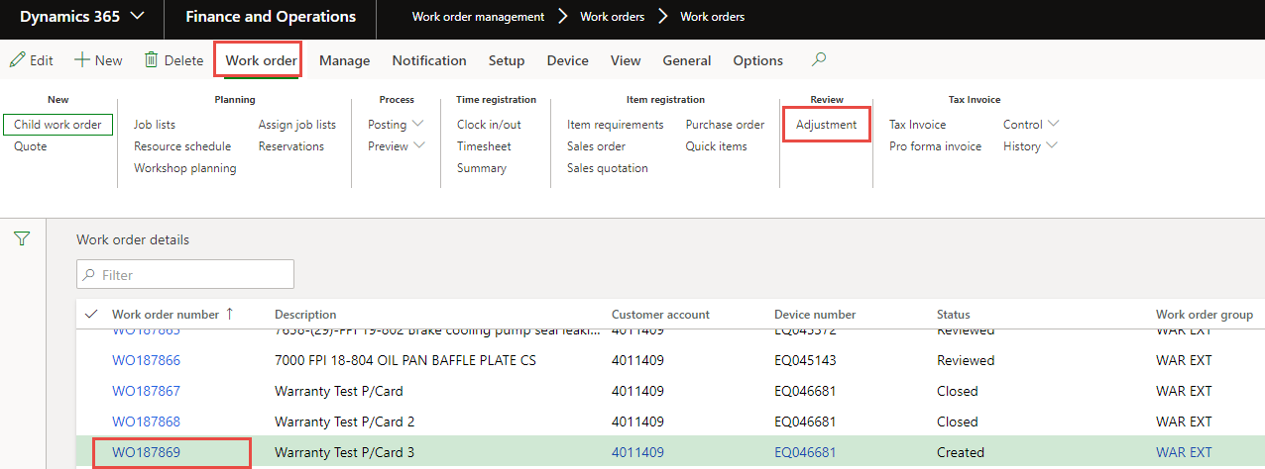
5. Selecting the Transaction for the P-Card you want to adjust. Select Adjust.  
   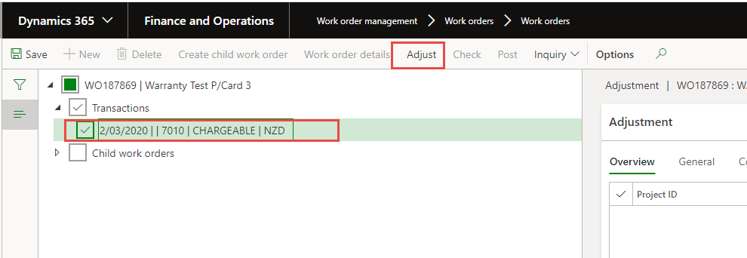
6. Adjustment Transactions appear you make the selections below - OK  
   
7. You can see the Description is blank or has incorrect data in it and the Sales Price same as Cost.  
   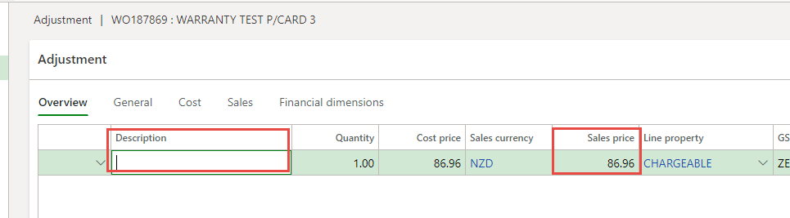
8. Change the Description or populate one and change the Sales Price to what you want the customer to pay. Select Financial Dimensions.  
   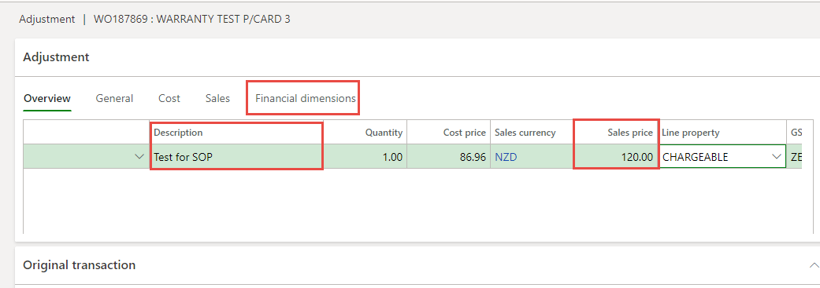
9. You can see that it has financial Dimensions.  
   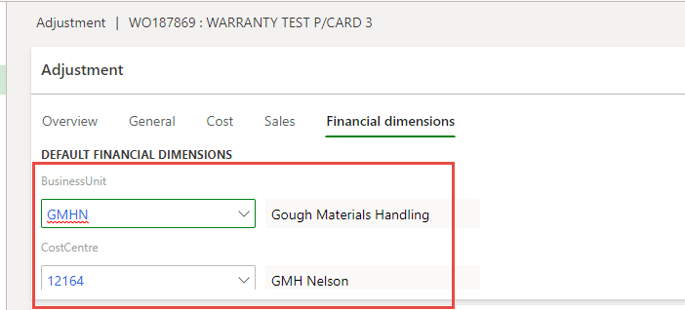
10. Save and then Post.  
    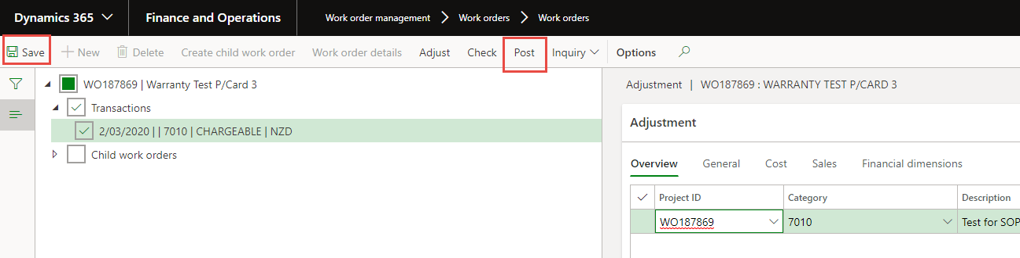
11. You should get this message which means the transaction has posted.  
    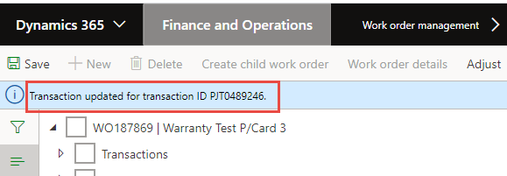
12. If you go back View the transactions, you will now see that the new transaction has the new Sales price.  
    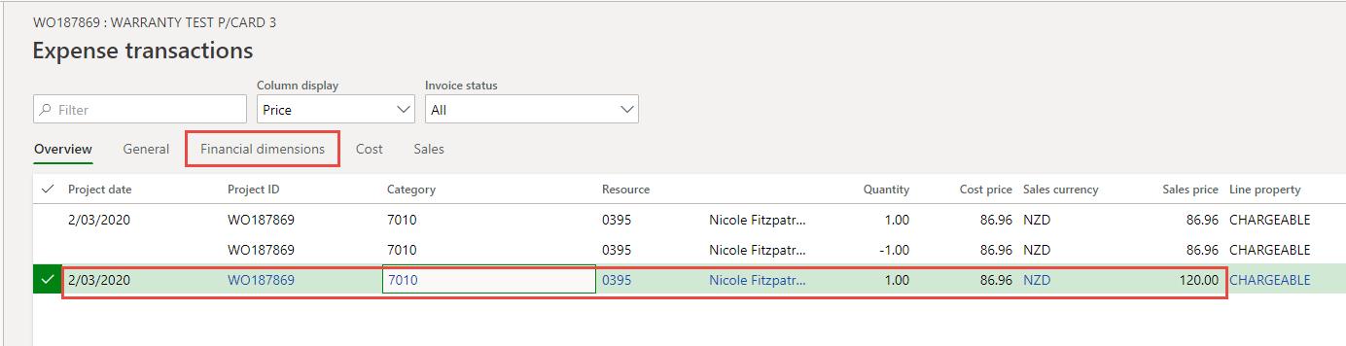

**Job List which Has STD Hours BUT Fee Line Created**

1. You have created a Fee line for the Labour, BUT the Work Order has a Job List. Or you are going to use the Project Labour line.
2. You go to Work Order > Time Registration > Timesheet.  
   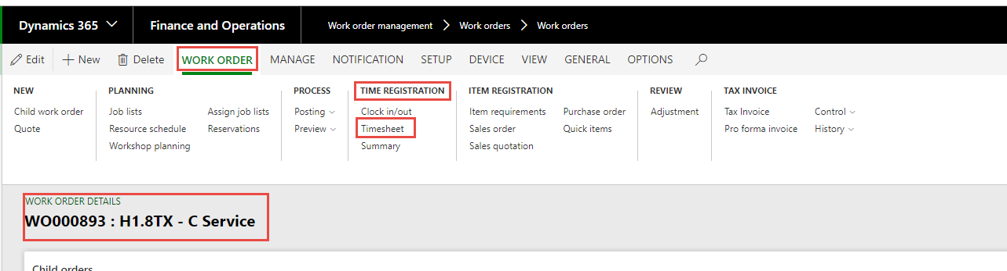
3. You will see that you have Project Hours and Standard Hours. The project hours are the actual hours that you posted to the Work order. Standard Hours are the ones that came for the Job List. Because you have Fee Lined the Labour you need to remove the STD Labour.  
   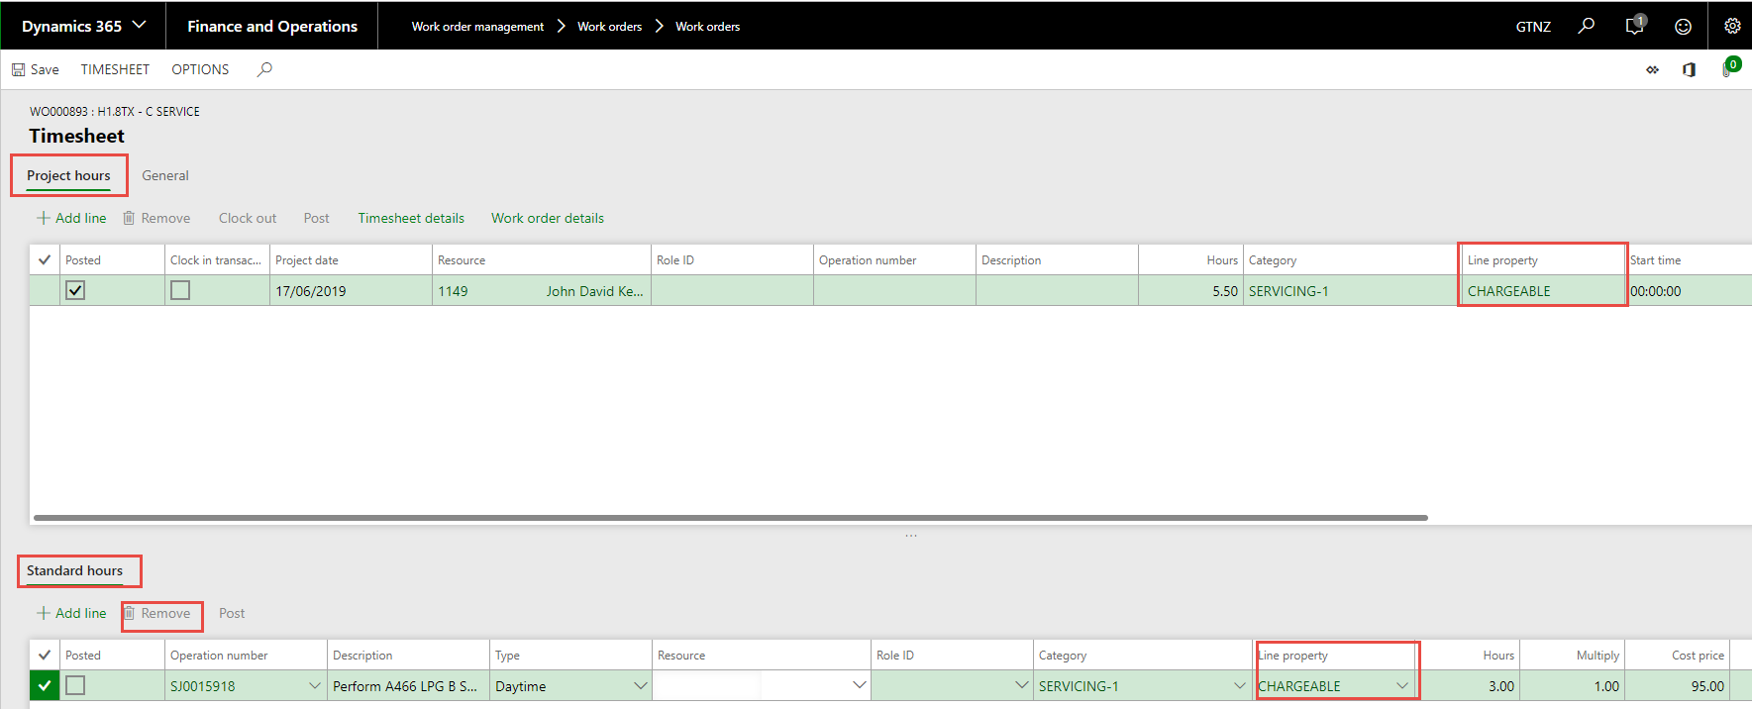
4. Select remove to delete the line. Select Yes.  
   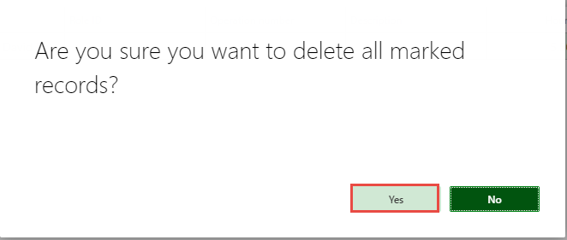
5. Close the Screen.

**P-Card Adjustments**

**We have an issue with the P/Card transaction – Annata-159531 – See notes below.**

**Make sure that you still need to do the adjustment for the value and the description as per below.**

When you try to Invoice the work order only if it has a P-Card transaction on it you will get the following error message

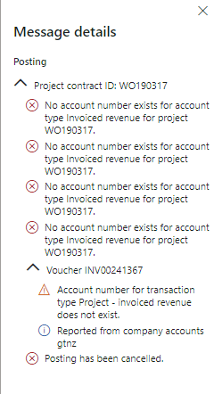

You need to raise a help desk ticket with the subject “P-Card Work order Work around”

Include the work order details and details as per normal for raising a ticket. When you get the ticket number by return e-mail you can then ring the Help desk, give them the number and they will do the fix that is required to get the work order to close.

**TRANSFER PARTS AND CONSUMABLES FROM ONE WORK ORDER TO ANOTHER – PRICING IS THE RETAIL NOT THE CUSTOMER AGREEMENT. CAS - 161251**

When you transfer the parts to another work order the customer pricing is not being populated it is picking up the retail price.

Three work arounds.

1. If the customer is the same as the original work order customer, then you can do the adjustment and check the pricing in the original transaction field at the bottom. You then change the price on the adjustment line.  
   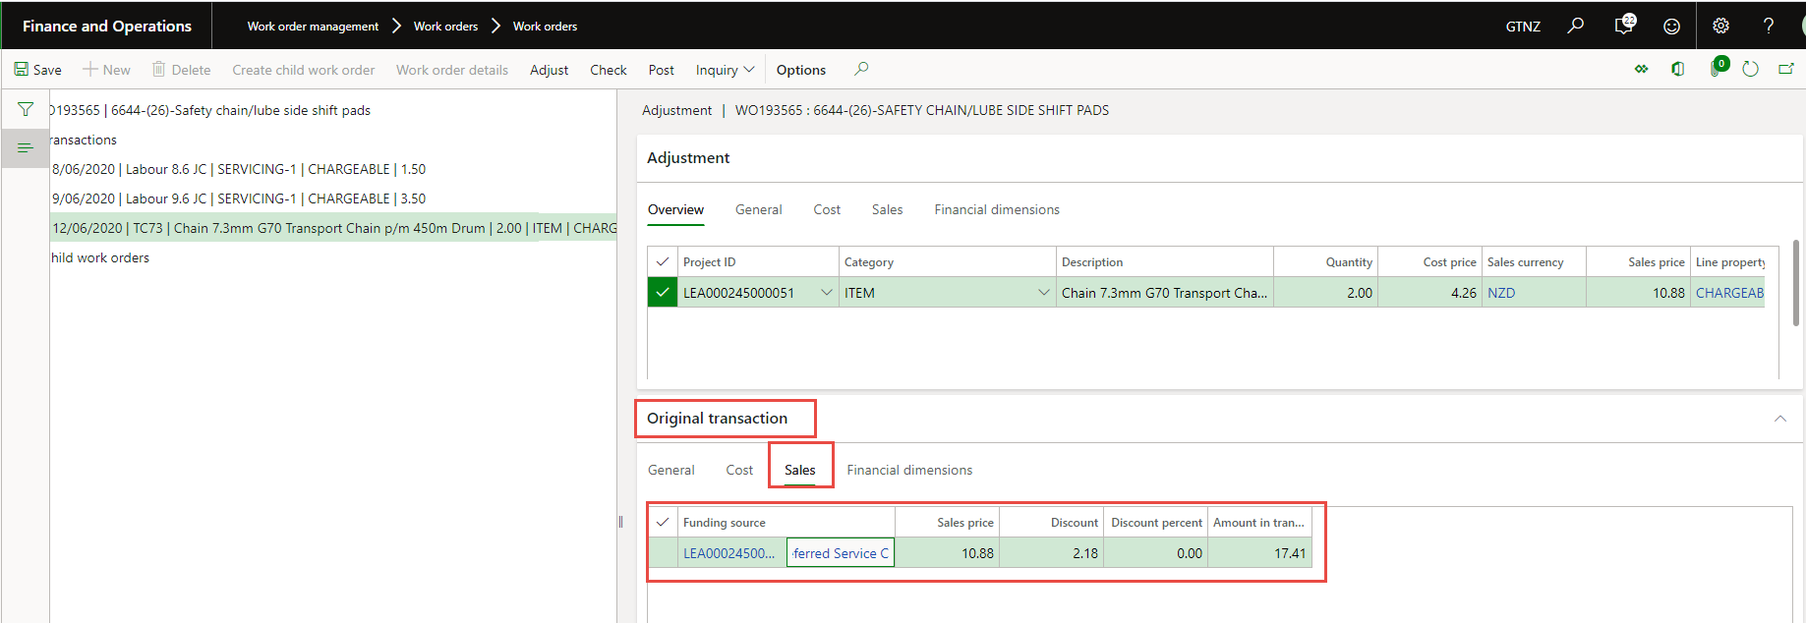
2. If they are different customers, or you are unsure if the price is correct then you need to return the parts to your warehouse -not 15H and then get parts to receive the credit and then re load them onto the new work order which will pick up the customer specific pricing if there is any. Some customers don’t have agreements for parts pricing.
3. On the new work order > Item Requirements add the parts to the line you will be transferring, you see that the pricing has come up, indicating that this customer has special pricing for parts. Record these prices.  
   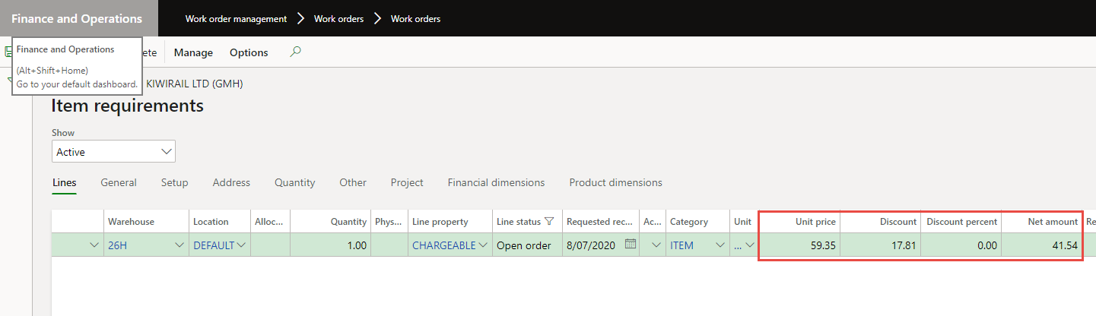

On the old work order do the adjustment/Transfer of the parts to the new one. You see that the price is different to the values you recorded.   
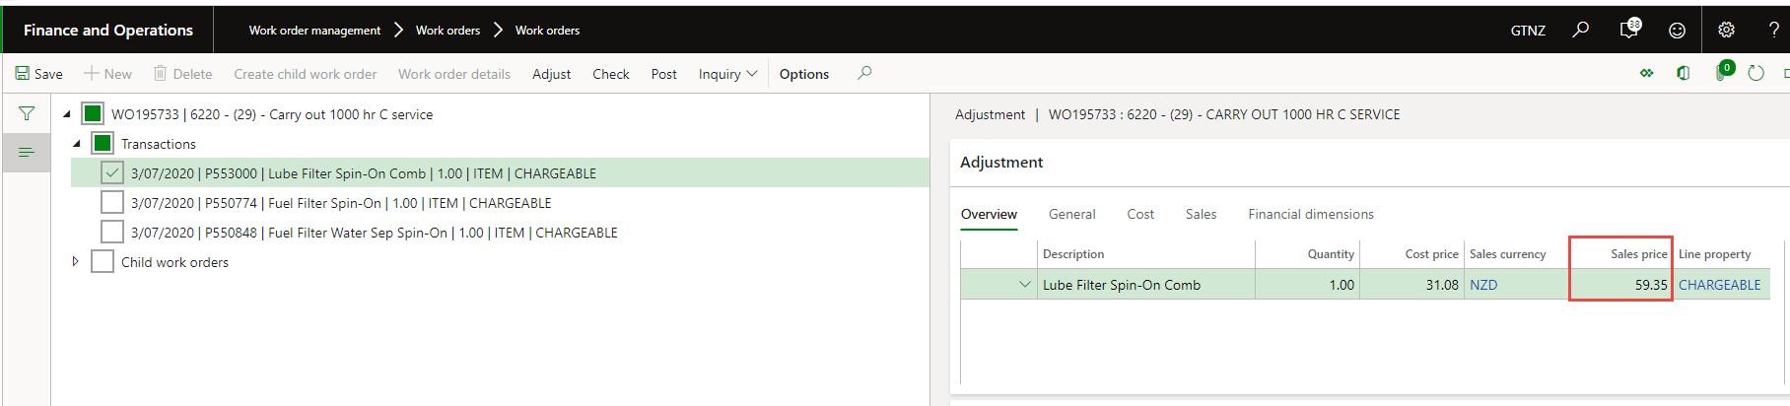

You change the Sales price to match the values you recorded and then you can post.  
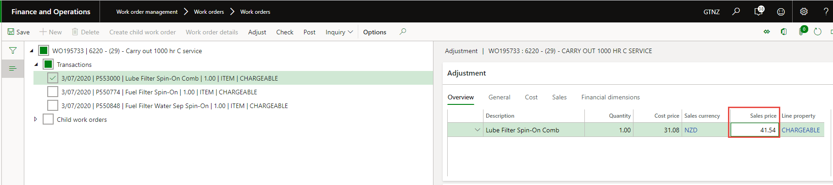

1. For Consumables as you load and post them then returning them is an easy process and then reload back onto the new work order that will guarantee you get the correct pricing.